School Uniform Policy 2023

Policy reviewed on: | October 2023
Policy is due for review no later than: | October 2025

Contents:
Statement of intent

- Legal framework

- Roles and responsibilities

- Cost principles

- Equality principles

- Complaints and challenges

- School uniform supplier

- Uniform assistance

- Non-compliance

- School uniform

- Adverse weather

- Labelling

- Monitoring and review

Appendices

  - School Uniform Assistance Application Form

Statement of intent
St Thomas CE (VC) Primary School believes that a consistent school uniform policy is vital to promote the ethos of the school and provide a sense of belonging and identity for all pupils, regardless of their protected characteristics or socio-economic circumstances.
This policy lays out the measures the school has taken to ensure a consistent, fair and inclusive uniform policy, and to implement a uniform that reflects the needs of all pupils, and is affordable and the best value for money for the school and pupils’ families.
We believe that pupils learn most effectively and achieve their best outcomes when they are comfortable, able to be themselves, and dressed in such a way that sets an appropriate tone for education.

Legal framework

This policy has due regard to all relevant legislation including, but not limited to, the following:

- Education and Inspections Act 2006
- Education Act 2011
- Human Rights Act 1998
- Equality Act 2010
- The UK General Data Protection Regulation (UK GDPR)
- Data Protection Act 2018
- Education (Guidance about Costs of School Uniforms) Act 2021

This policy has due regard to all relevant guidance including, but not limited to, the following:

- DfE (2021) ‘Cost of school uniforms’
- DfE (2021) ‘School Admissions Code’
- DfE (2021) ‘School uniforms’

This policy operates in conjunction with the following school policies:

- Complaints Procedures Policy
- Behaviour Policy

Roles and responsibilities

The governing board is responsible for:

- Establishing, in consultation with the headteacher and school community, a practical and smart
school uniform that accurately reflects the school’s vision and values.
- Ensuring that the school’s uniform is accessible and inclusive, and does not disadvantage any pupil by virtue of their protected characteristics or socio-economic status.
- Listening to the opinions and wishes of parents, pupils and the wider school community
regarding changes to the school’s uniform.
- Ensuring that the school’s uniform is accessible and affordable.
- Demonstrating how best value for money has been achieved in the uniform policy.
- Ensuring compliance with the DfE’s ‘Cost of school uniforms’ guidance.
- Processing and approving all eligible School Uniform Assistance Application Forms. The headteacher is responsible for:
- Enforcing the school’s uniform on a day-to-day basis.
- Ensuring that teachers understand this policy and what to do if a pupil is in breach of the policy.
- Listening to the opinions and wishes of the school community in regard to the school’s uniform
and making appropriate recommendations to the governing board.
- Providing pupils with an exemption letter as appropriate, e.g. for a pupil who has a broken arm and requires a loose-fitting top.

Staff members are responsible for:

- Ensuring that pupils dress in accordance with this policy at all times.
- Disciplining pupils who are in breach of this policy.
- Ensuring that pupils understand why having a consistent and practical school uniform is important, e.g. school identity.

Parents are responsible for:

- Providing their children with the correct school uniform as detailed in this policy.
- Informing the headteacher if their child requires a more relaxed uniform policy for a period of time, including why.
- Ensuring that their child’s uniform is clean, presentable and the correct size. Pupils are responsible for:
- Wearing the correct uniform at all times, unless the headteacher has granted an exemption.
- Looking after their uniform as appropriate.
- Understanding and respecting why a school uniform is important to the school, e.g. school identity and community.

Cost principles

The school is committed to ensuring that its school uniform is affordable and accessible to all pupils, and does not place an unreasonable financial burden on parents.
In accordance with the ‘School Admissions Code’, the headteacher will ensure that the school’s
uniform policy does not discourage parents from applying for a place for their child.
The school will assess the overall cost implications of its uniform policy regularly, including prior to making any changes to the school uniform. When evaluating whether costs are reasonable and proportionate, the school will take into account the opinions and situations of:

- Economically disadvantaged parents.
- Parents with multiple children who are, or will be in the future, pupils at the school.
- Parents of younger children, as they are likely to grow quickly and require new sets of uniform more frequently.
- Parents of pupils with protected characteristics that may impact their ability to access the uniform due to costs.
- LAC and PLAC.

The school will evaluate the cost of its uniform based on the overall collection of uniform items that parents would need to purchase for a pupil, rather than on the cost effectiveness of individual items; this will include consideration of the fact that parents will need to purchase multiples of certain items,
  - shirts and socks, to ensure their child can come to school in clean uniform every day.
The school keeps variations in school uniform for different groups of pupils, e.g. year group-specific items or house colours, to a minimum where possible to ensure that pupils can get the most wear out of their uniform possible and that parents can pass some items down to younger siblings.
The school keeps branded uniform items to a minimal level that is reasonable for all members of the school community. The school defines a branded uniform item as any item of clothing that cannot be purchased at a range of retailers, including by virtue of logos, colours, design and fabrics. Where the school decides to require an item of branded clothing, it will conduct an assessment to ensure prices are kept as low as possible, e.g. by offering sew- or iron-on logo badges for jumpers that can be bought at retailers instead of requiring special branded jumpers.
The school is committed to meeting the DfE’s recommendations on costs and value for money. Every care is taken to ensure that our uniforms are affordable for all current and prospective pupils, and that the best value for money is secured through reputable suppliers.
The school works with multiple suppliers to obtain the best value for money possible. Any savings negotiated are passed to parents where possible and does not enter into exclusive single supplier contracts or cash-back arrangements. More information on supplier processes can be found in the ‘School uniform supplier’ section of this policy.

The school will not amend uniform requirements regularly and will take the views of parents and pupils into account when considering any changes to school uniforms.

Equality principles

The school takes its legal obligation to avoid discriminating against any protected characteristic unlawfully very seriously, and aims to ensure that the uniform policy is as inclusive as possible so that all pupils are supported to access a school uniform which is comfortable, suitable for their needs, and reflects who they are.
The school will work to ensure that school uniform’s cost does not disproportionately affect any pupils by ensuring that uniforms for all genders are as equal in price as possible and by adhering to the cost principles laid out in section 3.
The school will ensure that parents and pupils are consulted over any changes to school uniform, and that views and advice is sought specifically from pupils, and parents of pupils, who:

    - Are transgender, including non-binary pupils.
    - Have SEND and/or sensory needs.
    - Are of a religious or cultural background that has dress requirements.

The school implements a gender-neutral uniform, meaning that pupils are not required to wear specific items based on their gender, and may wear any of the uniform items listed in the ‘School uniform’ section of this policy regardless of the legal sex recorded on the school’s records.
Transgender pupils are supported to access the uniform that best reflects their gender expression.
The school ensures that pupils who are required to follow certain dress requirements, e.g. by virtue of their membership of a particular religious or cultural group, are afforded flexibility to allow them to wear a uniform that adheres to their requirements as far as possible. The school endeavours to meet all requests for amendments to the uniform for these purposes; however, will ensure that the needs and rights of individual pupils are weighed against any health and safety concerns for the entire school community.
Parents’ concerns and requests regarding religious clothing are dealt with on a case-by-case basis by the headteacher and governing board, and always in accordance with the school’s Complaints Procedures Policy.
The school ensures that the needs of pupils with SEND and/or sensory difficulties are considered in the uniform policy, e.g. ensuring soft, stretchy fabrics and avoiding intricate buttons or hard seams; however, where the needs of these pupils cannot be met in the standard uniform policy, individual adaptations to the uniform will be considered and permitted wherever possible.

Complaints and challenges

The school endeavours to resolve all uniform complaints and challenges locally and informally, in
accordance with the school’s Complaints Procedures Policy.
To make a complaint, parents should refer to the Complaints Procedures Policy and follow the stipulations outlined.
When a complaint is received, the school works with parents to arrive at a mutually acceptable outcome.
Governors are willing to consider reasonable requests for flexibility to allow a pupil to accommodate particular social and cultural circumstances.

School uniform supplier

Our current school uniform suppliers are:

NATASHA
2 Buxton Way New Street Huddersfield HD1 2UL 01484 431260
www.natashaschoolwear.co.uk

TERM TIME WEAR
5 St Johns Road Huddersfield HD1 5AY
01484 453534
www.termtimewear.com

The governing board will ensure that a contract is in place with the supplier for branded items.
The school will retender the uniform contract every five years, whether changes to the uniform are made or not, in line with the Tendering and Procurement Policy. The governing board will be able to demonstrate how uniform is procured at the best value for money. The headteacher will work to ensure that the items are procured as cheaply as possible without compromising on the quality, e.g. by requesting standard-style items from the supplier rather than more intricate and unique designs. The school does not sign contracts with suppliers before requesting visualisations of proposed uniform, as well as fabric samples.

Uniform assistance

The school supports vulnerable families with school uniform. The school works with Uniform Exchange to help ensure every child has access to school uniform.

The school holds second-hand school uniforms in the school office for parents to access; access to these uniforms is available upon request made to the headteacher. Parents are invited to donate their child’s uniform when they no longer need it.

School uniform School colours
Our school colours are as follows:

    - Navy
    - Blue
    - Grey

Clothing
The school uniform is as follows: See Appendix 1.

Jewellery
Permitted jewellery that may be worn is:

    - One pair of stud earrings – no other piercings are permitted.
    - A smart and sensible wrist watch.

Jewellery is the responsibility of the pupil and not the school. Lost or damaged items will not be refunded. All jewellery must be removed during practical lessons, including PE lessons and science experiments.

Hairstyles
The school reserves the right to make a judgement on where pupils’ hairstyles or hair colours are inappropriate for the school environment; however, will ensure that any such judgements do not discriminate against any pupil by virtue of their protected characteristics.

Adverse weather

All pupils are required to wear weather-appropriate clothing that covers as much of their skin as possible during adverse weather.
For hot temperatures, this includes wearing:

    - Loose-fitting and lightweight shirts and dresses with sleeves and collars or covered necklines.
    - Over the knee skirts, shorts or trousers.
    - Tops that cover the shoulder area.
    - Sunglasses with UV protection when outside, where possible.

Pupils are advised not to wear any jumpers or cardigans during heatwaves. If outside during break times, pupils not wearing sun-safe clothing are advised to stay in an area protected from the sun, or spare clothing is provided.
For cold temperatures, this includes wearing:

    - Scarfs, gloves, coats and hats when they are outside.
    - Warm jumpers that conform to the school’s uniform policy.
    - Trousers, or thick tights with skirts.

Labelling

All pupils’ clothing and footwear is clearly labelled with their name.
Any lost clothing is be taken to the lost property box in the school office. All lost property is retained for half a term and is donated to Uniform Exchange if it is not collected within this time.

Monitoring and review

This policy is reviewed every 2 years by the chair of governors and the headteacher.

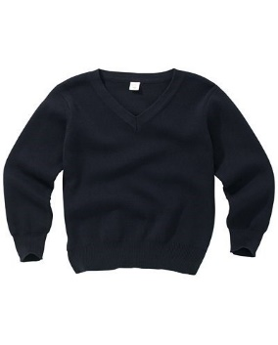
JE W E LLE RY
UNIFO RM POLI CY

Ideally no jewellery should be worn to school. If necessary we will permit:

Small stud earrings
Sikh Kara bracelets

Please note earrings must be removed for swimming lessons in KS2.

HAIR ACC ESSOR IES
should be discreet and in school colours.

UNIFO RM STOCK ISTS

NATASHA
2 Buxton Way New Street Huddersfield HD1 2UL 01484 431260
www.natashaschoolwear.co.uk

TERM TIME WEAR
5 St Johns Road Huddersfield HD1 5AY
01484 453534
www.termtimewear.com

Free recycled uniform is also available to Kirklees residents from UNIFORM EXCHANGE
www.uniform-exchange.org

IT EMS AV AIL ABL E I N SCHOO L

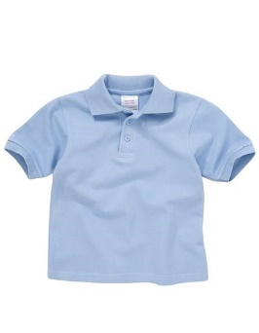
V-neck navy sweatshirt with school logo

Blue polo shirt
for Reception up to Year 4

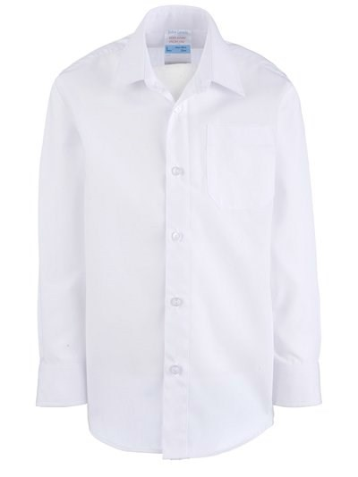
Formal white shirt with
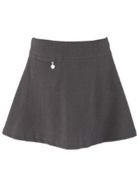
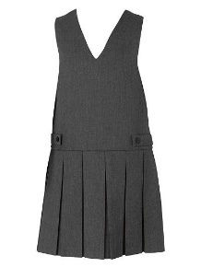
school tie for Years 5 & 6

Ties

Book bags Pump bags PE shorts
Swimming hats

Baseball caps* Sun hats Beanie hats

* baseball caps with other logos are not allowed in school

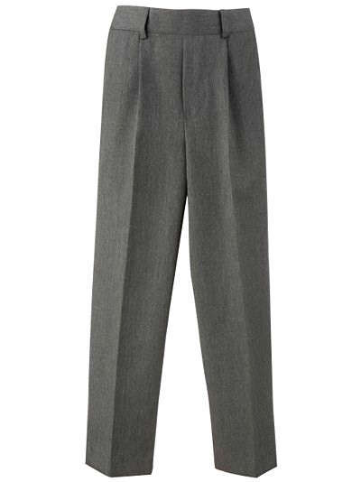

Grey trousers,
skirt or pinafore

Opt io na l
Var iati on s

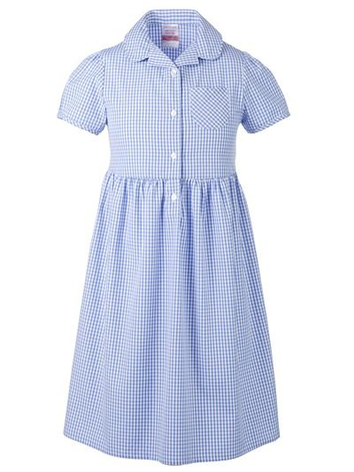

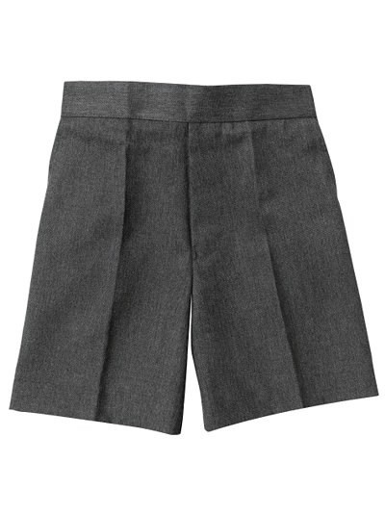

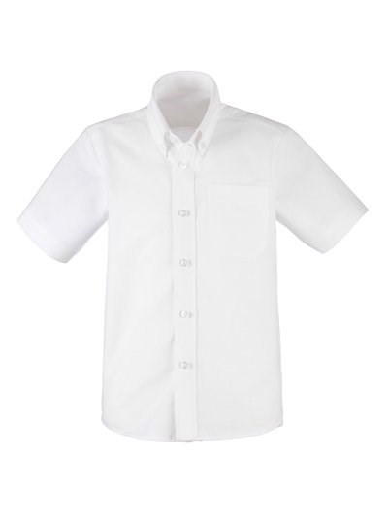

Ties should still be worn with short sleeved shirts.

White leggings may be worn under
summer dresses if necessary.

Black leggings may be worn under winter skirts if necessary.

A navy blue headscarf
may be worn if required.
P E KIT

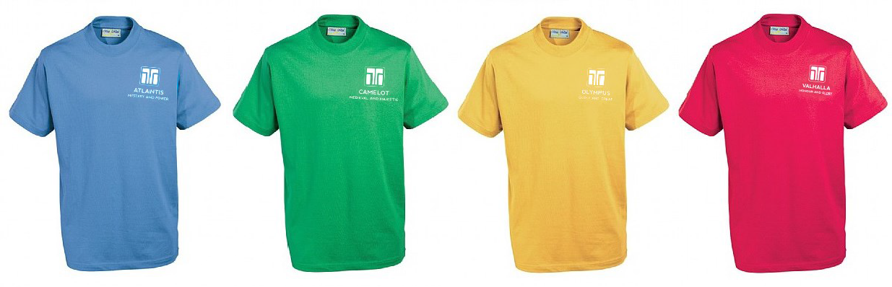

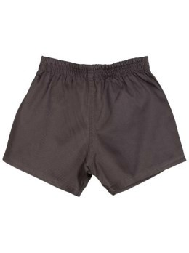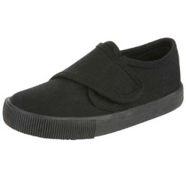

T-shirt in house colour with house logo, black shorts and black pumps.

Plain black tracksuit bottoms or leggings can be worn in winter for outdoor sessions.

FOO TW E AR

We ask all children to wear sensible. plain black, leather/leather look footwear with no logos or excessive embellishments.

No heels, open toes or slip-on ballet shoes in the interests of health & safety.

If wellies or non-uniform boots are worn in winter for the journey to school, children should bring a change of shoes or wear their black PE pumps indoors.

COATS

Children should wear a warm, waterproof coat.

Hoodies and sweatshirt style jackets
are not allowed in school.

