READING

Reading Knowledge Sequence
At St Thomas Primary we want children to become fully immersed in their class book and develop a love of reading to ensure they become lifelong readers.

Substantive Knowledge
We believe that a secure foundation in basic skills is crucial to progression in reading. This is because a skilled reader requires accurate, speedy word reading alongside good language comprehension. It is our aim that our pupils leave school fluent in the building blocks of reading: syntax, context, vocabulary, knowledge of narrative structure, prosody and fluency. This is why at St Thomas Primary, all pupils are taught a broad curriculum that will allow them to comprehend increasingly complex texts which are selected not only on the ‘difficulty’ of their semantics and syntax but also on their layout, linguistic features, levels of meaning, text structure, narration style, and their references to different cultures and concepts.

The Building Blocks of Reading

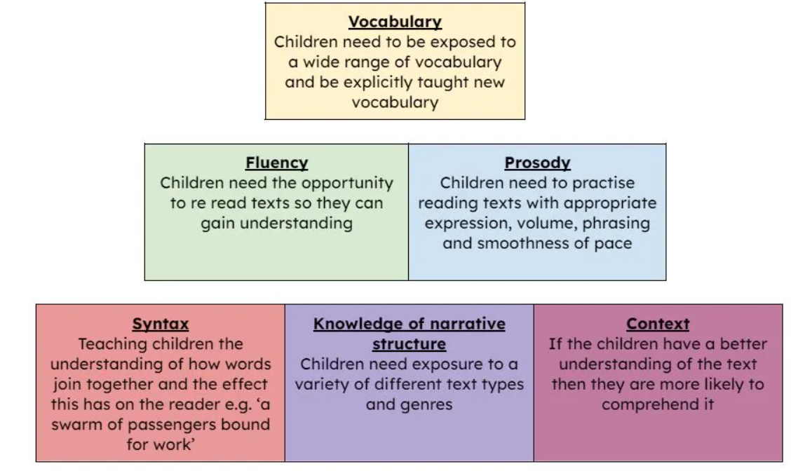

Disciplinary Knowledge

We use a 7-stage format to teaching reading across Year 2 and KS2, which allows children to develop a deeper understanding of the book and gives them the opportunity to apply the basic skills and building blocks of reading.

Activate Prior Knowledge: In this stage, children are asked to make predictions about the book based on what they already know through word association and themes. Pupils may use the front cover, blurb, images or vocabulary that might appear in the book to help form predictions.

Reading and Fluency: This stage provides pupils with the time to develop their reading fluency and prosody. Teachers model with confidence and pupils have the opportunity to read out aloud. Often there is a reading focus based on what the majority of pupils need to work on.

Initial Thoughts and Observations: In this stage, children are given background information and context they need to be able to access the book. They may read to or listen to a paragraph/chapter of the book and are given the opportunity to raise questions allowing for discussions and debate. Pupils have the opportunity to wonder and think aloud e.g. ‘I wonder…’, ‘I can see…’, ‘I feel…’

Breakdown and Repair: Pupils are taught a range of strategies to breakdown unknown words and phrases in order to gain a clearer understanding of the text they are reading. Pupils are encouraged to consider what they don’t yet know, what confuses them and words they are not sure of.

Delve at a Deeper Depth: This aims to explore the book further and to delve into themes, characters and language present within a book. This stage deepens the thinking and encourages pupils to interrogate the text. It is covered in many different ways such as conscience alley, debates, freeze frames, character interviews, visualisation, in order to ensure that children are fully engaged and really understand their book.

Comprehension Questions: This stage often has a reading domain focus based around data analysis. Teachers identify gaps in learning and cover the domains which require extra teaching and focus. During this stage pupils are encouraged to think aloud to gain a better understanding of the questions asked, they are encouraged to find evidence and construct both meaningful oral and written responses.

Summary: This stage can be done at any point through the whole process. Pupils are encouraged to demonstrate a clear understanding of an extract, page, chapter and/or the whole text if needed.

