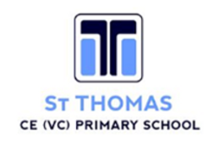

**How we teach Reading at**

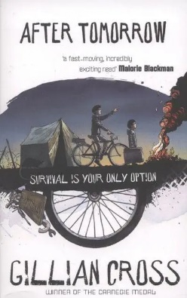**St Thomas Primary.**

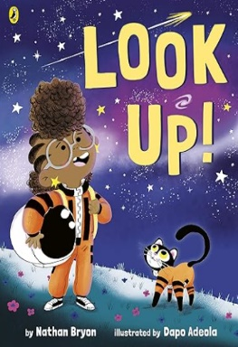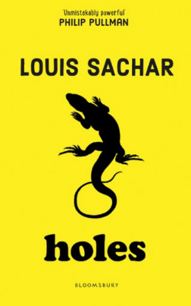

**Intent**

I have a rich and varied knowledge of vocabulary and grammar.

I read and respond to a wide range of texts.



I use phonics to decode unfamiliar words and read fluently.

I read for pleasure and know that my thirst for knowledge and success is harnessed through books.

|  |  |
| --- | --- |
|  | **YEAR GROUP MUST READS** |
| Reception |  |
| Year 1 |  |
| Year 2 |  |
| Year 3 |  |
| Year 4 |  |
| Year 5 | ;; |
| Year 6 |  |



At St Thomas Primary School, our entire school community recognises the vital role that reading plays in raising standards across the curriculum. That’s why we make it our top priority to ensure that all pupils become fluent, confident, engaged and successful readers, reaching the highest possible standards.

Reading is at the heart of our teaching across all subjects. We are committed to embedding a strong reading culture at the very core of everything we do.

**Phonics**

At St Thomas Primary School we use the Essential Letters and Sounds as our Systematic Synthetic Phonics programme. This programme is followed with rigor and fidelity by all teachers and teaching assistants. Discrete whole-class phonics lessons are taught to all children, daily in Year’s Reception 1 and 2. To ensure that learning is embedded, flashcards and reading opportunities continue throughout the day and additional phonics teaching is given to identified children. Phonics remains the main strategy that we use to approach/decode unfamiliar words and spelling across the school. We believe we can teach all children to read and that all children can love reading.

Children working within the ELS programme have their reading books selected by the class teachers and teaching assistants to match the sounds that they are currently working on or need to practice. This way the books become a focused tool to support progress.

Individual phonics assessments are completed every half term for all children working within ELS. The phonics leader then uses this information to identify the pupils who need extra intervention. Continuous formative assessment is carried out during lessons and this is used to inform any same day intervention or catch up.

Children who have been identified as ‘working below the required standard’ have daily intervention to help them get back on track. We continue to use ELS. structures and processes for intervention.

**Reading lessons in KS1 and KS2**

As children progress through school, we build on their existing reading experiences to develop fluency, word-level knowledge, comprehension, and independence. At St Thomas Primary School, we use a consistent 4/7-stage reading format from Year 1 through Year 6. This rigorous approach fosters confidence and enjoyment in reading, enabling pupils to deepen their knowledge as they advance. For 30 minutes, four days a week, pupils engage in a variety of enjoyable, age-appropriate yet challenging activities designed to enhance fluency, word recognition, and comprehension. Our teaching promotes high-quality talk and discussion within a language-rich environment. Partner and group discussions are encouraged, with pupils speaking in complete sentences and taking turns appropriately. The time allocated to each stage is informed by data, and both staff and pupils are familiar with the format, terminology, and activities involved at each stage.

**The 7-stage teaching sequence (disciplinary knowledge):**

1. **Activate Prior Knowledge:** Pupils make predictions about the text using clues like the front cover, blurb, images, and key vocabulary, drawing on what they already know.
2. **Reading and Fluency:** Pupils develop fluency and prosody by listening to teacher modelling and reading aloud themselves. They focus on rereading familiar sections to improve understanding and confidence.
3. **Initial Thoughts and Observations:** Pupils receive background information and context, then read or listen to parts of the text. They share questions and thoughts aloud to promote discussion and curiosity.
4. **Breakdown and Repair:** Pupils learn strategies to decode unfamiliar words and phrases, with explicit teacher modelling. They reflect on confusing parts and vocabulary gaps to improve comprehension.
5. **Comprehension Questions:** Focused on addressing gaps identified through data, pupils think aloud, find evidence, and practice forming clear oral and written responses to questions. Comprehension lessons focus on one domain at a time to allow targeted teaching, which helps close specific gaps, builds pupil confidence, improves skill retention, and makes progress easier to assess. Lessons follow an I do, we do, you do approach, gradually building pupil independence through scaffolding.
6. **Delve at a Deeper Depth:** Pupils explore themes, characters, and language in depth through engaging activities such as debates, role-plays, and visualisation to deepen understanding.
7. **Summary:** At any point, pupils summarise extracts, chapters, or the entire text to demonstrate clear understanding.

**In Year 1,** reading lessons are taught every other week and concentrate on the first four stages of the 7-stage format — Activate Prior Knowledge, Initial Thoughts and Observations, Reading and Fluency, and Breakdown and Repair — with an emphasis on fluency, vocabulary development, and word recognition. These lessons foster a culture of discussion and engagement and immerse pupils into books, supporting writing outcomes.

**In Year 2,** pupils follow the 7-stage reading format, concentrating on the first five stages: Activate Prior Knowledge, Initial Thoughts and Observations, Reading and Fluency, Breakdown and Repair, and Comprehension Questions. In the latter part of the academic year, the final two stages—Summary and Delve Deeper—are introduced to promote higher-order thinking and deeper engagement with texts.

Years 3–6 cover all seven stages, with the time allocated to each stage determined by analysis of previous reading assessment data, through which gaps in learning are identified.

**Reading for Pleasure**

**Story Time**

At St Thomas Primary, pupils have the opportunity to listen to their teacher read aloud for 20 minutes, four times a week, during a dedicated story time session. This is timetabled immediately after lunchtime to help pupils settle and calm before engaging with wider curriculum projects in the afternoon. Story time is prioritised and takes place in a distraction-free environment, allowing children to become fully immersed in the text. It offers pupils the chance to listen to and engage with literature uninterrupted. Teachers read with confidence and enjoyment, modelling fluent reading with appropriate prosody and pace, bringing characters to life and exposing children to a diverse range of texts, including stories, poetry, rhymes, and non-fiction. During these sessions, teachers often encourage discussion, enabling pupils to express their understanding, preferences, and opinions about the text. Whole-class story time enriches children’s imagination, vocabulary, and comprehension, while also supporting their writing development.

**Book Club**

Once a week, pupils are also provided with a 20-minute session where teachers introduce new book titles and share recommended interesting reads. During this time, pupils are also encouraged to share and recommend their favourite books. This may be done through reading a chapter of their favourite book, introducing the main character, sharing fun facts they have learned as a result of reading a particular text.

**Review:**

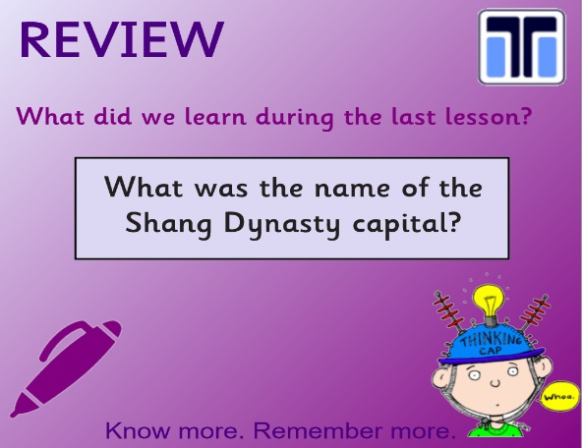Informed by previously covered knowledge, with the aim of revisiting and consolidating key themes and information.

**Learning Objective:**

This is written as the stage being covered by pupils in that particular lesson e.g. WALT: Breakdown and Repair.

**Steps to Success:**

Make clear what pupils should know (knowledge) and be able to do (skills) by the end of the lesson.

**Tasks:**

Pupils may work in groups, pairs, or individually on tasks that offer challenge and promote a deeper understanding. Tasks are completed directly in books or on digital platforms such as Seesaw. Floor books are also used to document practical learning and capture pupil voice. In Key Stage 1, tasks initially focus on developing fluency and vocabulary. This early focus helps free up cognitive load later, enabling pupils to engage more effectively in comprehension and understanding activities. As pupils progress into Upper Key Stage 2, they are encouraged to plan how they present their work, with minimal reliance on worksheets. Teachers foster a culture of discussion to support this development.

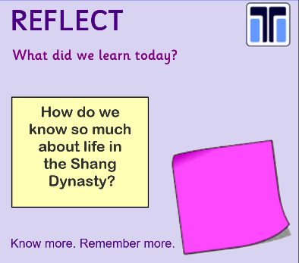**Reflect:**

At the end of each lesson, pupils should be given time to reflect on their understanding of the content taught. Teachers should allow sufficient time for this reflection, as it may reveal misconceptions or prompt further questions that need to be addressed.

Misconceptions and errors are further addressed through timely and effective feedback.

**Progression and continuity**

Progression in both skill and core knowledge is carefully and deliberately planned from Reception through to Year 6. It is essential that the sequence of lessons builds in a progressive and coherent way, equipping pupils with the necessary skills, understanding, and knowledge to develop secure word-level knowledge, strong comprehension, and reading fluency as they move through the school.

**Vocabulary**

At St Thomas Primary we expose our children to **rich and varied vocabulary**. This in turn…

**1. Supports Reading Comprehension:** A broad vocabulary helps children understand what they read. If they know the meaning of more words, they can make sense of texts more easily and engage with more complex ideas.

**2. Improves Spoken and Written Communication:** Rich vocabulary gives children the tools to express themselves clearly, accurately, and creatively.

**3. Builds Confidence and Curiosity:** When children understand and use a wide range of words, they feel more confident in classroom discussions and are more likely to ask questions, explore new topics, and participate in learning.

**4. Closes the Language Gap:** Vocabulary exposure can vary greatly depending on a child's background. Rich vocabulary teaching helps bridge this gap, giving all children the opportunity to access the curriculum fully and equitably.

**6. Enhances Thinking Skills:** Learning and using ambitious vocabulary encourages children to think more deeply and critically. It helps them make connections, categorise ideas, and reason more effectively.

**Adaptations/SEND**

The reading curriculum at St Thomas Primary is ambitious for all pupils, including those with SEND. Teachers hold high expectations for SEND learners, ensuring the curriculum is neither diluted nor unnecessarily reduced. Like all pupils, SEND students benefit from a carefully considered curriculum. We adopt an adaptive teaching approach, where teachers continuously assess learners’ strengths and needs and adjust their instruction accordingly. This approach allows the whole class to work towards the same learning goals, with tailored resources and support ensuring every pupil has the tools to succeed. Importantly, the core reading knowledge remains intact to avoid creating barriers for future learning. At St Thomas Primary, we consider the “4 S’s” when adapting lessons to meet diverse needs e.g. scaffold, scale, structure and style.

**Interventions**

Where children are working below the national expectation in reading for their age group, opportunities are provided throughout the day for additional support and guidance.

**Lowest 20% of Readers**

At St Thomas Primary School, we are proactive in identifying the lowest 20% of readers within each year group. Once identified, interventions are implemented swiftly and strategically to ensure pupils who are at risk of falling behind receive the support they need without delay.

Interventions are tailored to the individual needs of each pupil—for example:

• Extra phonics support (e.g. using the Essential Letters and Sounds programme),

• Fluency development, or

• Comprehension practice (e.g. using 60-second comprehension tasks).

All pupils in the lowest 20% access a minimum of three targeted intervention sessions per week. These sessions are designed to develop key reading components, including:

• Sounding and blending,

• Vocabulary acquisition,

• Fluency, accuracy, and automaticity,

* Comprehension.

To ensure impact, interventions are timetabled and prioritised to avoid cancellation.

**SEND Readers**

In addition to targeted phonics (ELS), fluency, and comprehension interventions, we provide a wide range of additional support to meet the individual learning needs of our SEND pupils. These interventions are carefully selected based on need and may include:

• Toe by Toe (structured literacy support),

• Progress in Learning,

• Black Sheep Press resources (speech and language development),

• Language for Thinking (developing reasoning and verbal comprehension skills),

• And many more specialist programmes tailored to specific areas of need.

**At Risk**

Alongside provision for the lowest 20%, detailed analysis of reading assessment data (formative), is used to identify pupils who are at risk of slipping behind or who are beginning to show signs of falling below age-related expectations.

Class teachers are promptly made aware of these pupils and are expected to make adaptations to planning in order to close emerging gaps e.g. the 4S’s.

**Classroom support**

Individual class teachers also timetable into the week, specific intervention-based activities based on test analysis and whole class, group or individual needs e.g. a comprehension group focusing on specific reading domain questions, morning work activities focusing on breaking down and understanding tricky words and phrases.

**Disadvantaged Readers**

Pupils who have been identified as disadvantaged, who are not working at nationally expected levels for their age group are also provided with timetabled intervention, based on their area of need.

**Assessment Reading**

Attainment is assessed at the end of every term using a written, unseen reading test based on [insert assessment name] for pupils in Years 1 to 5. In Year 6, reading is assessed more frequently through the use of past SATs materials and CGP SATs practice papers. The results are carefully analysed to identify gaps in learning, which then inform future planning and targeted interventions.