**St Thomas CE (VC)**

**Primary School**



**Collective Worship Policy**

|  |  |
| --- | --- |
| **Policy Reviewed on:** | **September 2023** |
| **Policy to be reviewed on:** | **September 2025** |

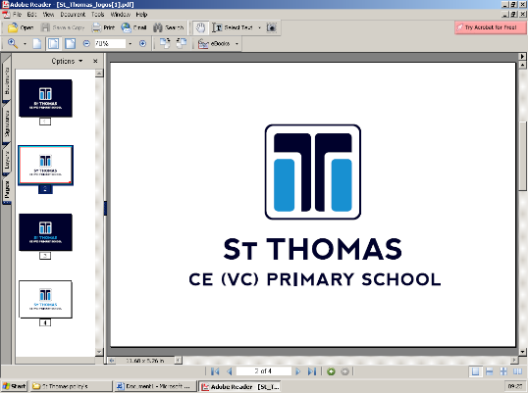

Collective Worship

**Collective Worship at St Thomas**

**Intent:**

Collective Worship contributes significantly to the ethos of St Thomas CE (VC) Primary school and it is our aim that it is a time when the school community can:

* share common aims and values
* explore school themes
* celebrate achievement and special times
* explore together the world in which we live
* develop a community spirit

We also intend that Collective Worship contributes to the development of the pupil as a ‘whole’ person by providing opportunities to:

* Explore and respond to a variety of forms of worship, thus enabling those pupils with a religious commitment to deepen their experience of worship, and to allow those without a religious commitment to begin to appreciate what worship means for others.
* Approach the threshold of worship by fostering in them an attitude characterised by feelings such as humility, awe, wonder, appreciation, thankfulness, respect, reverence and elation.
* Consider spiritual and moral issues and the many questions which relate to life.
* Acknowledge the things which have meaning, value and purpose for the pupils as individuals, as well as for the school and the wider community.
* Develop a sense of community within and beyond the school.
* Celebrate achievements, special occasions and special events in relation to individual pupils within school, to the school as a whole, or to the wider community.
* Acknowledge and respect difference and diversity.

**Special Educational Needs Disability (SEND) / Pupil Premium / Higher Attainers**

All children will have Quality First Teaching.  Any child with identified SEND or in receipt of pupil premium funding may have work additional to and different from their peers in order to access the curriculum dependent upon their needs. As well as this, our school offers a demanding and varied curriculum, providing children with a range of opportunities in order for them to reach their full potential and consistently achieve highly from their starting points.

**Implementation:**

Collective Worship time is distinct from curriculum time. However, in St Thomas CE (VC) Primary School, Collective Worship will at times feature aspects of the curriculum, which will enhance the experiences of pupils by reflecting on the work done in classes. At times, Collective Worship will enrich classwork through its consideration of subject matter from different perspectives.

The provision of opportunities for pupils’ spiritual, moral, social and cultural development is in line with school policy which informs our practice. To ensure Collective Worship provides opportunities for British values, spiritual, moral, social and cultural development. It should address a wide variety of themes and topics, use diverse stimuli and resources and provide pupils with the opportunity to ‘respond’ on their own level.

**Impact:**

The content of all acts of Collective Worship will be considered carefully, to ensure relevance and suitability for the ages, aptitudes and backgrounds of all pupils. Our termly planning sheets list the themes, special occasions and events, but will be flexible to allow the inclusion of current and topical issues. Our planning sheets ensure that there is continuity and progression, and enable the monitoring and evaluation of acts of worship to take place.

Visitors will be welcome to lead Collective Worship from time to time and will be given guidance on acts of Collective Worship at St Thomas CE (VC) Primary School. Leaders from Faiths within the area will increase the pupils’ awareness, promote respect and raise the esteem of the pupils who belong to these Faiths.

Each half term Collective Worship is organised to follow our six school values (Belong, Hope, Aspire, Believe, Love, Thank you) and will take place in the school halls, St Thomas church or within the classroom.

Acts of worship will usually last for approximately 20 minutes, although it is recognised that this time will be shortened or lengthened when it is appropriate.

**Monday:** Welcome to the week collective worship

**Tuesday:** Quiet reflection KS2

**Wednesday**: Singing and worship KS2

**Thursday:** St Thomas Church led collective worship in key stage 1 or 2 /In class collective worship

**Friday:** Celebration of effort Collective worship

The trinity candle is lit before worship begins and religious songs will be sung. Children are regularly involved in the worship, which starts and finishes with prayer and reflection and a blessing.

**Leadership and Management**

A representative from each class throughout school (years 2-6) form our school collective worship council who meet half-termly with the RE Lead. The role of the council is to plan, monitor and evaluate themes and outcomes of Collective Worship.

Members of our Senior Leadership Team, representatives from St Thomas Church, the RE Lead and occasional visitors will be involved in leading acts of worship throughout the school year.

**Monitoring and Evaluation**

Children have the opportunity to issue prayers through the school prayer portal or prayer slips for Collective Worship. RE Lead will carry out monitoring through pupil voice. A collective worship council consisting of pupils across different year groups meet to discuss, give idea and opinions on the delivery of collective worship.

**Partnerships with Parents**

Any parent who objects to their child attending an act or acts of Collective Worship may request that their child is withdrawn. Parents are encouraged to discuss this with the Head Teacher. Any pupil who is withdrawn from an act or acts of Collective Worship will be supervised during that time by a member of the school staff.

Management of the policy

Policy created by Miss S Dickson. To be reviewed 2025.