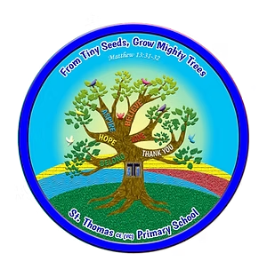

**St Thomas CE (vc) Primary Reading and Book Spine**

**Rational**

*This document is intended to support the progress of whole class quality reading across the school as well as offer a range of inspiring picture books that work well for T4W and books that link well to our topics. I have audited the books we already have as class sets (15+ books) for in school and added a few more titles to the range of recommended reads from many sources carefully researched. You may well find that some of the books you have used and loved have been moved into other year groups and some new and unknown books have been added. This is to ensure progression in reading as we need to ensure year groups are reading books that build on the ones read the previous year in both complexity and language.*

*I found we already had in school a number of books that linked well to our topic areas but we must ensure that they work well as readers also and some topics just have a very limited selection of related texts. However, I also appreciate that the linking of texts for some topics could be powerful and useful to showcase a depth and breadth of knowledge and text formats so I have attempted to link these to the topic areas in most cases. In the year that the book doesn’t match the topic, it is expected the that the book should be read anyway as it will either link to work done the previous year or work to be done in the following year.*

*We have endeavoured to provide a reading spine that has a range of age appropriate yet challenging books that span both modern and classic books, from texts where there is a complex narrative to texts with figurative and symbolic story plots. We also want to ensure that the books we read diverse in both their authors and characters as well as ensuring all our children are exposed to a range of books across a wide selection of genres. You will notice that there are 4/5 ‘chapter books’ provided for each year group as well as selection of topic related books, non-fiction and poetry. The picture books relating to T4W are well recommended and where they span year groups (e.g. Journey, Quest, Return – it is important they are covered).*

*A wide selection of these genres should be covered over the year in reading, writing and topic work. There is also the opportunity to add in a set of books that you enjoy as a teacher. Be careful with your selection- look at future planning when you might not be in that year group and make sure that the book has longevity. If not, Books Plus ‘lend out’ class sets of books which may be worth looking into and if buy a class set look out for books that are new, are diverse and would be picked up and enjoyed by future teachers and classes.*

*Don’t forget reading should also include songs, newspapers, comic books, diary entries, short pieces, scripts, short videos etc- sometimes these might work better if focusing on a particular skills or comprehension strand.*

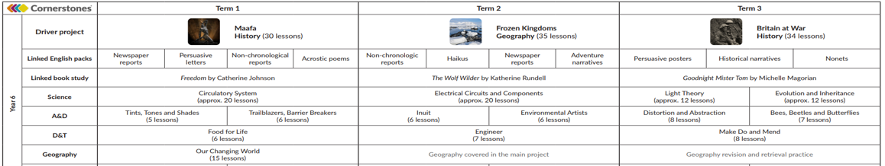**Topic themes**

6

|  |  |  |  |  |
| --- | --- | --- | --- | --- |
| ***Books to read for whole class reading***  ***(MUST BE READ)*** | ***Picture books that work well with writing*** | ***Books that link well with topic*** | ***Non-fiction books*** | ***Poetry*** |
| ***Kensuke’s Kingdom*** *(classic)Michael Morprugo*    ***After Tomorrow****- Gillian Cross*    ***Gorilla Dawn-*** *Gill Lewis*    **Hidden Figures-** Margot Lee-Shetterly  ***Wonder-*** *R. J. Palacio*    ***When the Sky Falls***   * *Phil Earle* | ***Way Home-*** *Libby Hathorn*    ***Tom Crean’s Rabbit-*** *Meradith Hooper*    ***Rose Blanche-*** *Ian McEwan* | ***Arctic Adventures*** *– Willard Price*  ***Trapped by the Ice-*** *Micheal McCurdy*  ***Friend or Foe****-Michael Morpurgo*    *The Wolf* ***Wilder –*** *Katherine Rundell*  ***Goodnight Mister Tom*** *– Michelle Magorian* | **Origin of Species** - Sabina Radeva   [*Expedition to the Arctic*](https://smile.amazon.co.uk/Expedition-Arctic-Traveling-Professor-Woolf/dp/1482415062/ref=sr_1_1?dchild=1&keywords=expedition+to+the+arctic&qid=1603359968&sr=8-1) *by Professor Alex Woolf* | [***https://clpe.org.uk/poetryline***](https://clpe.org.uk/poetryline)  ***Landscape with the Fall of Icarus -*** [William Carlos Williams](https://poets.org/poet/william-carlos-williams)- link to Another Time-  **Jabberwocky-** Lewis Caroll – link to Science  **Silver -** Walter de La Mare The Fish- Elizabeth Bishop **Dark Sky Park**- Philip Gross- *will fit well in Around Word in 80 days and My World Kitchen* |

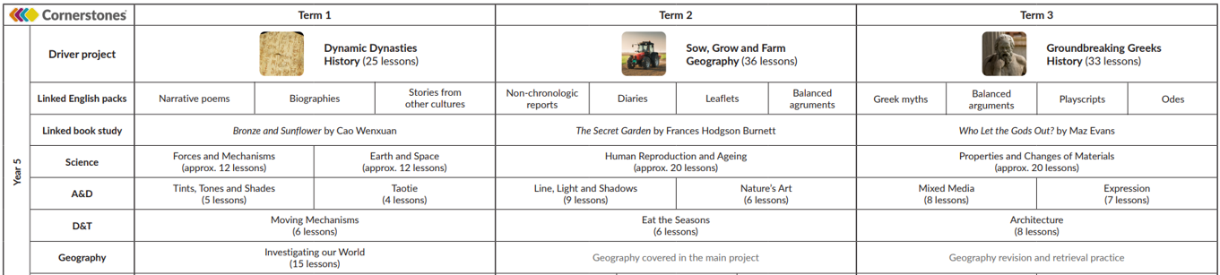**Topic themes**

5

|  |  |  |  |  |
| --- | --- | --- | --- | --- |
| ***Books to read for whole class reading***  ***(MUST BE READ)*** | ***Picture books that work well with writing*** | ***Books that link well with topic*** | ***Non-fiction books*** | ***Poetry*** |
| ***Holes-*** *(classic) Louis Sachar*    ***Night Bus Hero –****Onjali Q.Rauf*    ***Boy at the Back of the***  ***Class****- Onjali Q. Rauf*    ***Hacker-*** *Malorie Blackman*  ***The Promise –***  *Nicola Davies* | ***Return-*** *Aaron Becker (3/3)*    ***The Arrival –*** *Shaun Tan*  **Who let the Gods out –** Maz Evans | ***Tikki Tikki Tembo-***[*Arlene Mosel*](https://smile.amazon.co.uk/Arlene-Mosel/e/B001H6Q0A0?ref=sr_ntt_srch_lnk_1&qid=1603359374&sr=8-1)    **Secret Garden -**  Frances Hodgson Burnett | Shang Dynasty China –Tracey Kelly   **Ancient Greece –** Sandra Newman  **Ancient Greeks –** Stephanie Turnbull | [***https://clpe.org.uk/poetryline***](https://clpe.org.uk/poetryline)  ***Landscape with the Fall of Icarus -*** [William Carlos Williams](https://poets.org/poet/william-carlos-williams)- link to Another Time.  **The Tyger-** William Blake  **The Magic Box - Kit Wright**    **Dark Sky Park**- Philip Gross- *will fit well in Around Word in 80 days and My World Kitchen* |

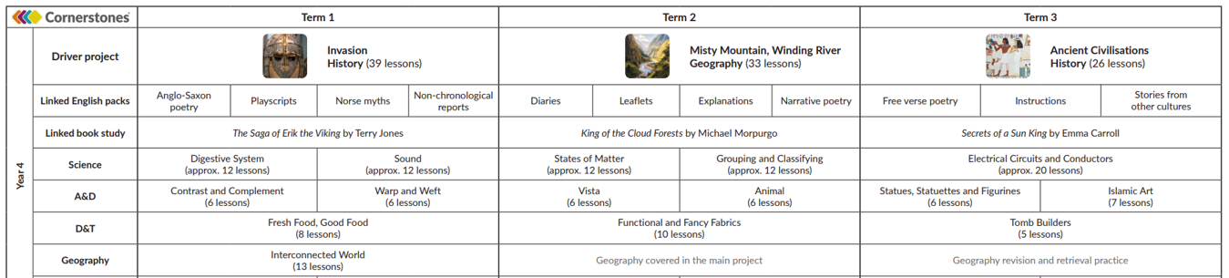

4

|  |  |  |  |  |
| --- | --- | --- | --- | --- |
| ***Books to read for whole class reading***  ***(MUST BE READ)*** | ***Picture books that work well with writing*** | ***Books that link well with topic*** | ***Non-fiction books*** | ***Poetry*** |
| ***Sky Hawk****-Gill Lewis*    ***Anglo-Saxon Boy-*** *Tony Bradman*    ***Secrets of a Sun King-*** *Emma Carroll*    **King of the Cloud Forests –** Michael Morpurgo | ***Quest-*** *Aaron Becker (2/3)*  ***Beowulf-*** *Michael Morpurgo* | ***Fairy Tales*** *–*   *Terry Jones*    ***How to be a Viking in 15 easy steps-*** [Scoular Anderson](https://smile.amazon.co.uk/s/ref=dp_byline_sr_ebooks_1?ie=UTF8&field-author=Scoular+Anderson&text=Scoular+Anderson&sort=relevancerank&search-alias=digital-text) | *Great Women who saved the Planet*  *by Professor Alex Woolf*  ***Guardians of the Planet:*** *How to be an Eco-Hero*  *by*[*Clive Gifford*](https://smile.amazon.co.uk/Clive-Gifford/e/B001I9QMYA/ref=dp_byline_cont_book_1) *Invasions!* *James Mason*  [***Everything: Ancient Egypt***](https://www.amazon.co.uk/Everything-Ancient-National-Geographic-Kids/dp/0008267804/ref=sr_1_1?crid=NPTCKOM88TIO&dchild=1&keywords=everything+ancient+egypt&qid=1604587078&s=books&sprefix=everything+ancie%2Cstripbooks%2C143&sr=1-1)  *by*[*National Geographic Kids*](https://www.amazon.co.uk/National-Geographic-Kids/e/B075712CCN?ref=sr_ntt_srch_lnk_1&qid=1604587078&sr=1-1)    [***See Inside Your Body***](https://www.amazon.co.uk/dp/0746070055/ref=rdr_ext_tmb)*by*[*Katie Daynes*](https://www.amazon.co.uk/s/ref=rdr_ext_aut?_encoding=UTF8&index=books&field-author=Katie%20Daynes) | [***https://clpe.org.uk/poetryline***](https://clpe.org.uk/poetryline)  **The Sound Collector-** Roger McGough Being Brave At Night - By Edgar Guest   **The Lost Words**- by Jackie Morris and Robert Macfarlan  **A Kid in my Class**- By Rachel Rooney |

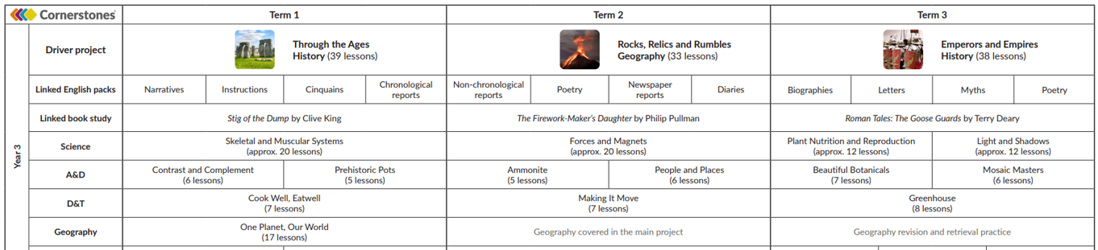

3

|  |  |  |  |  |
| --- | --- | --- | --- | --- |
| ***Books to read for whole class reading***  ***(MUST BE READ)*** | ***Picture books that work well with writing*** | ***Books that link well with topic*** | ***Non-fiction books*** | ***Poetry*** |
| ***The Iron Man-*** *(classic)Ted Huges*    ***Boy who Biked the World****- Alistair Humpreys*    ***Stig of the Dump-*** *(classic)Clive King*    ***Born to Run*** *- Michael Morpurgo*    **A bus called Heaven-** Bob Graham | ***Journey-*** *Aaron Becker (1/3)*  ***The Stolen Spear –*** *Saviour Pirotta*    ***Escape from Pompeii-*** *Christina Balit* | ***Rama and Sita-***[*Arlene Mosel*](https://smile.amazon.co.uk/Arlene-Mosel/e/B001H6Q0A0?ref=sr_ntt_srch_lnk_1&qid=1603359374&sr=8-1)   *Illustrated Grimm's Fairy Tales* ***Max the Champion*** *Sean Stockdale*  ***The Goose Guards –*** *Terry Deary* | [*An Anthology of Intriguing Animals*](https://www.amazon.co.uk/Anthology-Intriguing-Animals-Ben-Hoare/dp/024133439X/ref=sr_1_1?crid=248XIGHKFDKPT&dchild=1&keywords=animal+anthology&qid=1604587016&s=books&sprefix=animal+an%2Cstripbooks%2C164&sr=1-1) *by*[*Ben Hoare*](https://www.amazon.co.uk/Ben-Hoare/e/B001JP27WO?ref=sr_ntt_srch_lnk_1&qid=1604587016&sr=1-1) [*Discover & Learn: History - Romans in Britain*](https://www.amazon.co.uk/KS2-Discover-Learn-History-Britain/dp/1782941975/ref=sr_1_1?dchild=1&keywords=CGP+Romans&qid=1604587144&s=books&sr=1-1)  *by*[*CGP Books*](https://www.amazon.co.uk/CGP-Books/e/B00E0L0CBM?ref=sr_ntt_srch_lnk_1&qid=1604587144&sr=1-1)  ***Record Breakers!*** *More than 500 Fantastic Feats*  *by*[*DK*](https://www.amazon.co.uk/DK/e/B072JMLPDS/ref=dp_byline_cont_book_1)    [***DKfindout! Stone Age***](https://smile.amazon.co.uk/DKfindout-Stone-Age-DK/dp/0241282705/ref=sr_1_2?dchild=1&keywords=the+stone+age&qid=1604399373&sr=8-2)  *by*[*DK*](https://smile.amazon.co.uk/DK/e/B072JMLPDS?ref=sr_ntt_srch_lnk_2&qid=1604399373&sr=8-2)*and [Klint Janulis](https://smile.amazon.co.uk/Klint-Janulis/e/B07846J1MG?ref=sr_ntt_srch_lnk_2&qid=1604399373&sr=8-2)*  ***What the Romans did for us:***  *by*[*Alison Hawes*](https://smile.amazon.co.uk/Alison-Hawes/e/B0034O42JE?ref=sr_ntt_srch_lnk_1&qid=1604399459&sr=8-1) | [***https://clpe.org.uk/poetryline***](https://clpe.org.uk/poetryline)  **Chocolate Cake -**Michael Rosen Firework Poem *by James Carter*  ***All My Great Excuses****- Kenn Nesbitt*    **Revolting Recipes-** Roald Dahl    **A Kid in my Class**- By Rachel Rooney |

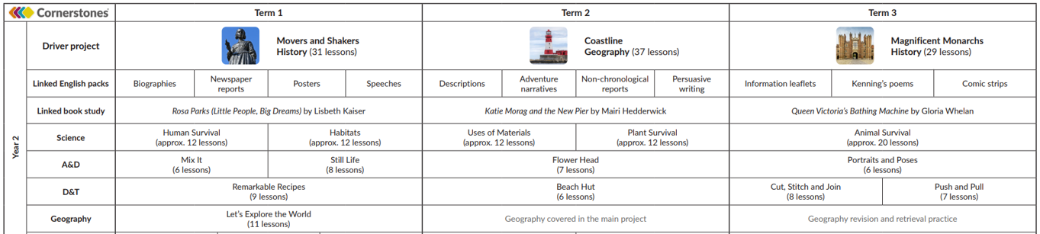

2

|  |  |  |  |  |
| --- | --- | --- | --- | --- |
| ***Books to read for whole class reading***  ***(MUST BE READ)*** | ***Picture books that work well with writing*** | ***Books that link well with topic*** | ***Non-fiction books*** | ***Poetry*** |
| ***The Hodgegheg-*** *(classic)Dick King-Smith*    ***Owl who was Afraid of the Dark-*** *Jill*   *Tomlinson*    ***George’s Marvellous Medicine-*** *Roald Dahl*   [*Look Up!*](https://www.amazon.co.uk/Look-Up-Nathan-Bryon/dp/0241345847/ref=sr_1_1?dchild=1&keywords=look+up&qid=1604587441&s=books&sr=1-1) *by*[*Nathan Bryon*](https://www.amazon.co.uk/Nathan-Bryon/e/B08MFQ7L33?ref=sr_ntt_srch_lnk_1&qid=1604587441&sr=1-1) | [*Ruby’s Worry: A Big Bright Feelings Book*](https://www.amazon.co.uk/Rubys-Worry-Tom-Percival/dp/1408892154/ref=sr_1_1?crid=2GL5V082CSREZ&dchild=1&keywords=rubys+worry&qid=1604587484&s=books&sprefix=Rub%2Cstripbooks%2C290&sr=1-1) *by*[*Tom Percival*](https://www.amazon.co.uk/Tom-Percival/e/B00KPNXR3O?ref=sr_ntt_srch_lnk_1&qid=1604587484&sr=1-1)    ***After the Fall How Humpty Dumpty Got Back Up***  *by Dan* [*Santat*](https://www.amazon.co.uk/s/ref=rdr_kindle_ext_aut?_encoding=UTF8&index=books&field-author=Santat,%20Dan&search-alias=digital-text)  [***Lazy Lion***](https://smile.amazon.co.uk/dp/0340565659/ref=rdr_ext_tmb) *Mwenye* [*Hadithi,*](https://smile.amazon.co.uk/s/ref=rdr_ext_aut?_encoding=UTF8&index=books&field-author=Hadithi,%20Mwenye) *Adrien ne [Kennaway,](https://smile.amazon.co.uk/s/ref=rdr_ext_aut?_encoding=UTF8&index=books&field-author=Kennaway,%20Adrienne)*    ***Katie Morag and the New Pier -*** Mairi Hedderwick | [***Vlad and the Great Fire of London***](https://www.amazon.co.uk/Vlad-Great-Fire-London-History/dp/099552050X/ref=sr_1_1?crid=3AKJTPRL4JPII&dchild=1&keywords=vlad+and+the+great+fire+of+london&qid=1604587810&s=books&sprefix=Vlad%2Cstripbooks%2C161&sr=1-1)  *by*[*Kate Cunningham*](https://www.amazon.co.uk/Kate-Cunningham/e/B076JQ6KL4?ref=sr_ntt_srch_lnk_1&qid=1604587810&sr=1-1)    ***Jesse Owens- A record breaker-***[*Arlene Mosel*](https://smile.amazon.co.uk/Arlene-Mosel/e/B001H6Q0A0?ref=sr_ntt_srch_lnk_1&qid=1603359374&sr=8-1)    ***Rosa Parcs –*** *Little people, big dreams – Lisbeth Kaiser*  ***Katie Morag and the New Pier -*** *Mairi Hedderwick*  ***Queen Victoria’s Bathing Machine*** *– Victoria Whelan* | *How Flowers Grow (Usborne Beginners)*  *Emergency Rescue: Meet Real-life Heroes DK Readers Level 3*[*100 Facts Penguins*](https://smile.amazon.co.uk/100-Facts-Penguins-Camilla-Bedoyere/dp/1848101031/ref=sr_1_1?crid=221D8AJQ44BZ2&dchild=1&keywords=100+facts+about+penguins&qid=1605006709&quartzVehicle=95-1833&replacementKeywords=facts+about+penguins&sprefix=100+facts+abot%2Caps%2C160&sr=8-1) *by*[*Camilla de la Bedoyere*](https://smile.amazon.co.uk/Camilla-de-la-Bedoyere/e/B004MZOVSQ?ref=sr_ntt_srch_lnk_1&qid=1605006709&sr=8-1)   *The Great Fire of London- Emma Adams* | [***https://clpe.org.uk/poetryline***](https://clpe.org.uk/poetryline)  ***I Do Not Mind You Winter Wind-*** *Jack Prelutsky*  ***Autumn is Here-*** *Top Marks* *The great fire of London- George Szirtes* [***Billy McCool***](https://clpe.org.uk/poetryline/poems/billy-mccool)  *By*[*Aoife Mannix*](https://clpe.org.uk/poetryline/poets/mannix-aoife)  [**https://clpe.org.uk/poetryline/poems/billy-mccool**](https://clpe.org.uk/poetryline/poems/billy-mccool)  *Good for Cool and Crazy Creatures* |

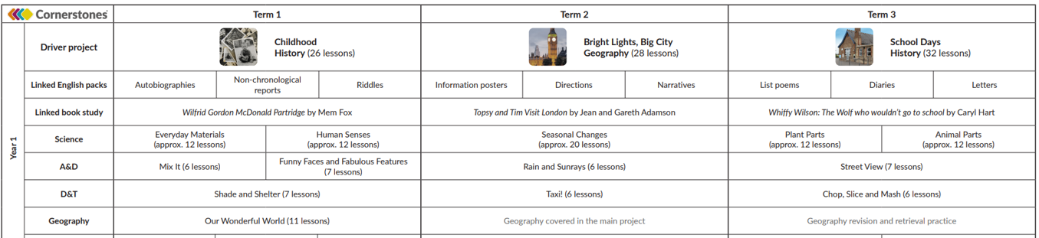

1

|  |  |  |  |  |
| --- | --- | --- | --- | --- |
| ***Books to read for whole class reading***  ***(MUST BE READ)*** | ***Picture books that work well with writing*** | ***Books that link well with topic*** | ***Non-fiction books*** | ***Poetry*** |
| ***Owl Babies-*** *Martin Waddell*    ***Where the Wild Things are***(classic) ***-*** *Maurice Sendak*   [*Wake*](https://www.amazon.co.uk/Look-Up-Nathan-Bryon/dp/0241345847/ref=sr_1_1?dchild=1&keywords=look+up&qid=1604587441&s=books&sr=1-1) *Up Do-* *by*Julia Donaldson  ***Penguin Small-*** *Mick Inkpen*  ***Hair Love-*** *Matthew A Cherry* | ***Voices in the Park-*** *Anthony Browne*    ***Voices in the Park-*** *Anthony Browne*    ***Dogger-*** *Shirley Hughes*    **Olympig**-  *Victoria Jamieston*  ***Traditional tales to read and explore:***  Rumpelstiltskin  The Pied Piper  Jack and The Beanstalk  Follow this on with some Aesop’s Fables. | ***No Bot-*** *Sue Hendra*    **Last Stop on Maket Street**-  [*Matt de la Peña*](https://www.amazon.co.uk/Matt-de-la-Pe%C3%B1a/e/B001IXRRQI/ref=dp_byline_cont_book_1)  **Dogger**-  [*Shirley*](https://www.amazon.co.uk/Matt-de-la-Pe%C3%B1a/e/B001IXRRQI/ref=dp_byline_cont_book_1) *Hughes*    *Mem Fox*    ***Topsy and Tim Visit London –*** *Jean Gareth Adamson*  **Whiffy Wilson – The Wolf who wouldn’t go to school** – Carly Hart | [***First***](https://www.amazon.co.uk/dp/0746070055/ref=rdr_ext_tmb) ***book of Nature***  *by*[*Nicola*](https://www.amazon.co.uk/s/ref=rdr_ext_aut?_encoding=UTF8&index=books&field-author=Katie%20Daynes) *Davis* *We Build our Homes- Laura Knowle*  [*999-*](https://smile.amazon.co.uk/100-Facts-Penguins-Camilla-Bedoyere/dp/1848101031/ref=sr_1_1?crid=221D8AJQ44BZ2&dchild=1&keywords=100+facts+about+penguins&qid=1605006709&quartzVehicle=95-1833&replacementKeywords=facts+about+penguins&sprefix=100+facts+abot%2Caps%2C160&sr=8-1) *What’s your emergency?* *by Maria Sare* | [***https://clpe.org.uk/poetryline***](https://clpe.org.uk/poetryline)  [***Please Mrs Butler***](https://clpe.org.uk/poetryline/poems/please-mrs-butler) - *By*[*Allan Ahlberg*](https://clpe.org.uk/poetryline/poets/ahlberg-allan)  ***Winter Trees-*** *By*[*George Szirtes*](https://clpe.org.uk/poetryline/poets/szirtes-george)  **Shuffle and Squelch***- Julia Donaldson and Nick Sharratt*  [***The***](https://clpe.org.uk/poetryline/poems/billy-mccool) ***Proper Way to Greet a Hedgehog and other ‘How to’ poems-***  *by*[*Paul B. Janeczko*](https://www.amazon.co.uk/s/ref=dp_byline_sr_book_1?ie=UTF8&field-author=Paul+B.+Janeczko&text=Paul+B.+Janeczko&sort=relevancerank&search-alias=books-uk)  [https://clpe.org.uk/poetryline/teaching-resources/clippa-teaching-sequences/proper-way-meet-hedgehog-and-other-how-poems](https://clpe.org.uk/poetryline/teaching-resources/clippa-teaching-sequences/proper-way-meet-hedgehog-and-other-how-poems%20) *Good for instructional writing* |

**RECEPTION**

|  |  |  |  |  |  |
| --- | --- | --- | --- | --- | --- |
| **Autumn 1 – Me and My Community** | **Autumn 2 – Once Upon a Time** | **Spring 1 – Starry Night** | **Spring 2 – Dangerous Dinosaurs** | **Summer 1 – Sunshine and Sunflowers** | **Summer 2 – Big Wide World** |
|  |  |  |  |  |  |