Reception Newsletter
2nd March 2023
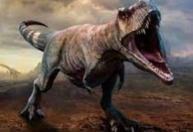
What are we learning?
Dangerous Dinosaurs

This half term, the children are learning about dangerous dinosaurs! This exciting project teaches children about the different animals that roamed Earth millions of years ago and how they are related to animals that live on Earth today. We have already learnt lots of new and exciting facts that your child may have shared with you already;

- Dinosaurs lived millions of years ago.
- Dinosaurs are now extinct.
- Dinosaur bones are called fossils.
- People who dig for dinosaur bones are called palaeontologists.
- Some dinosaurs were herbivores, this means they ate plants.
- Some dinosaurs were carnivores, this means they ate meat.
- A t-rex was a carnivore. His teeth were as big as bananas.
- Dinosaurs laid eggs.
In the classroom we have added lots of new and exciting areas for the children to learn about dinosaurs. We have added a digging area where the children can pretend to be palaeontologists and uncover dinosaur bones. We have added stories and non-fiction books to the book corner so that children. We have created an amazing small world area in our outdoor area with lots of mud, grass, rocks and toy dinosaurs so that the children can use their imaginative play. In PE we learnt how to move our bodes like the dinosaurs and create different shapes. We also learnt to do the Go Noodle Dino Stomp dance, which the children loved! Here are some photographs from our wonderful classroom.

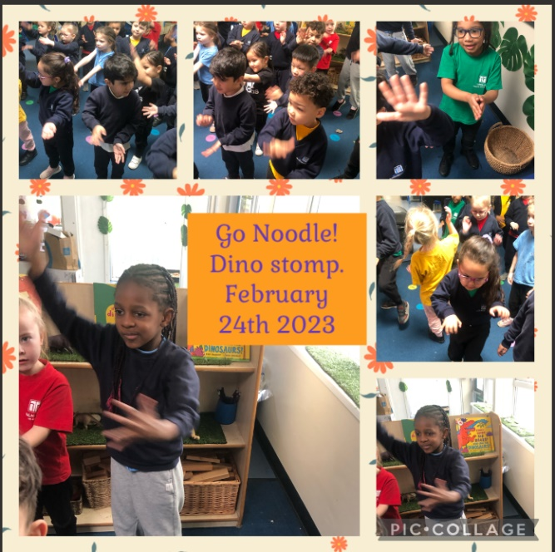
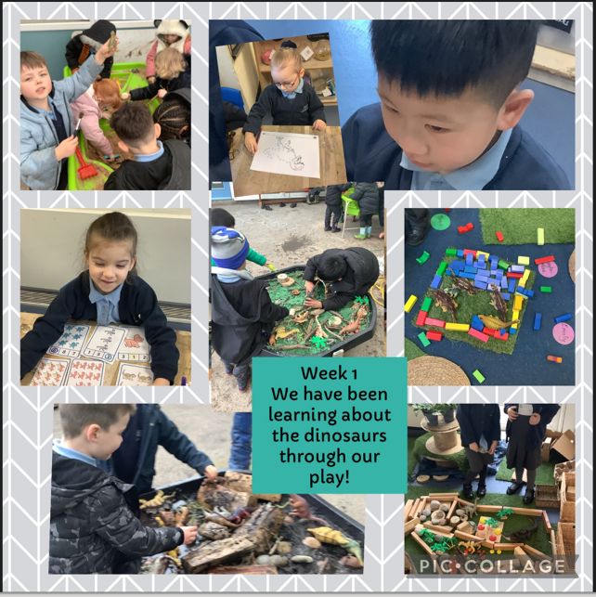

We have added some videos and some exciting activities to support and extend your child’s learning at home on our class seesaw page.

This week we shall be sharing the brilliant story, ‘Am I Yours,’ by Alex Lattimer. It tells the story of a dinosaur egg that is looking for his Mummy and Daddy. We have added a link to this story on our Seesaw page. We shall be receiving the delivery of a dinosaur egg to the classroom to look after and wait to see which dinosaur hatches from it!

The children will be drawing pictures of the dinosaur that they think is inside the egg. We shall be making salt dough and clay fossils. We shall also be making dinosaur eggs using paper mâché and balloons. It will be a super week of learning.

Messages to Parents

Snack Money
We would like your help again to raise additional funds to buy extra resources to support this brilliant topic. Last week the children celebrated pancake day and we used your donations to buy ingredients for making pancakes and adding toppings! Your donations really do help us buy those extra things! We appreciate all of your support. We collect every Monday morning.
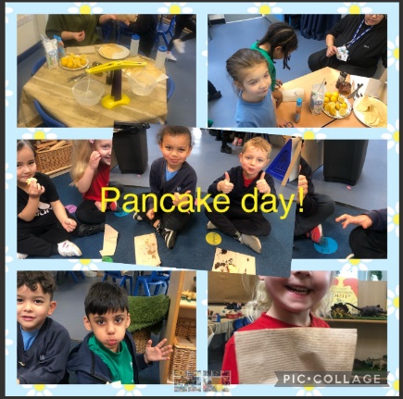
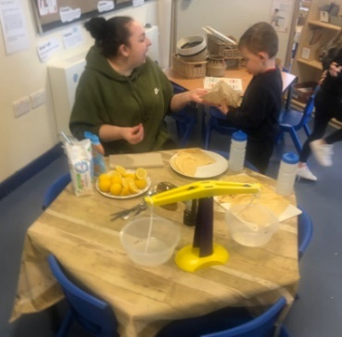

Junk modelling materials.
Please can you save any of the following for our junk modelling area. There are now two large white fabric bins outside each class for you to put your donations into.
- Tubes e.g., toilet rolls, kitchen rolls
- Cardboard boxes
- Lids
- Yoghurt pots
- Foil trays
- Plastic trays

Outdoor area
For those of you who collect your child from Miss James class, you may have noticed that the the children are now using the covered area for sand and water play. We have decided to develop this area and the grassed area opposite as we feel they are brilliant spaces for outdoor learning. Children have access to outdoor play every day. Outdoors is a brilliant space in which children can move freely and explore the world around them. We are working on creating the following areas;

- A large water play area
- A mud kitchen
- An outdoor music area with pans, wooden spoons, lids etc.
- Reading areas with covered dens and cushions.
- Digging area where children can dig for worms and even dinosaur bones!
- A building area where children can create using large wooden blocks, tyres and crates
- A sensory area with different plants such as lavender and herbs.

We are extremely fortunate that Mrs Wilson’s husband has created a water wall for the children and they are fascinated playing with this. He has added tubes and funnels to a crate to make this for the children. We are so grateful for this donation!
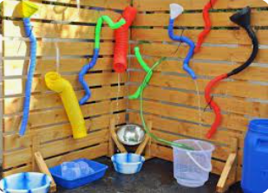

We would welcome your help with donating any materials or time to help us make new areas for the children such as;
- Tyres- if anyone knows a garage who could donate us some tyres for climbing and balancing
- Old pots and pans, tubes, large metal dishes, wooden spoons, large tins etc for creating a music wall on our fence.
- tarpaulin, old tents for making reading dens.
- Large plant pots, cuttings from plants.
- Log slices! If anyone knows a tree cutter or gardener who could donate large logs for the children to sit on.
- Large buckets, tubes, guttering, watering cans, large jugs.
- Cable reels- for making tables or using as wheels!
- Large pallets for making a stage for children to perform their dances and songs!

If you think you can help with time or resources, please speak to your child’s class teacher. We would really appreciate any support

Kind regards
Miss James and Miss Stoker

