**St Thomas CE (VC)**

**Primary School**



**Foreign Languages Policy**

|  |  |
| --- | --- |
| **Policy Reviewed on:** | **October 2023** |
| **Policy to be reviewed on:** | **October 2024** |

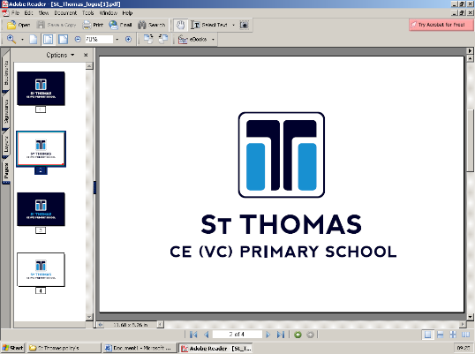

**Foreign Languages**

*Subject Policy*

**MFL at St Thomas CE VC Primary School**

**Intent:**

This policy outlines the purpose, nature and management of the teaching and learning of all aspects of the primary languages curriculum at St Thomas CE VC Primary School. This document describes the aims and principles for the teaching of French. It has been written by the MFL coordinator and adopted by the school leadership team, the teaching staff and governors.

Studying a language in primary school provides children with skills that are essential for the twenty-first century. As well as giving them the opportunity to learn a second language, an increasingly important skill in our globalised society, it also helps to promote and develop a broader intercultural understanding. The study of a second language also supports children’s literacy and oracy in school, by raising awareness of aspects of their own language(s), thereby enriching their understanding of both.

Our aim is to encourage a life-long learning of languages among our pupils in order to enhance their understanding of the world and their future economic well-being. Our main objective in the teaching of a foreign language at primary school is to promote the early development of linguistic competence and an understanding of other cultures. We believe that to accomplish this, we should help the children to do all of the following:

* familiarise themselves with the sounds of a foreign language in spoken form;
* familiarise themselves with the written form of a foreign language;

• begin to understand a new language, and communicate using it;

• make comparisons between languages;

• learn about different countries and their people, and work with materials from different countries and communities, thus increasing their awareness of other cultures;

• develop a positive attitude towards the learning of foreign languages in general;

• use their knowledge of the foreign language with growing confidence, both to understand what they hear and read, and to express themselves in different ways;

• acquire, through all of the above, a sound basis for further study at Key Stage 3 and beyond.

**Special Educational Needs Disability (SEND) / Pupil Premium**

The teaching of a language in Key Stage 2 at St Thomas is a statutory requirement and forms parts of a curriculum entitlement for all. The school aims to ensure that all children have opportunities to access and benefit from learning a foreign language together according to their needs. Therefore, all pupils regardless of race, gender, special educational needs or language spoken at home will have the opportunity to develop this language capability in school. Care will be taken to ensure that a variety of language learning activities and strategies are deployed in order to engage and motivate all learners. SEND children have access to the curriculum through variation of task, grouping or support from an adult.

**Implementation:**

For every pupil in key stage 2, learning a language is a statutory foundation subject. The programme of study for KS2 sets outs the new national requirements for the curriculum in languages which, amongst other things, requires substantial progress to be made in one language across the key stage. At St Thomas, we teach French in Years 3 to 6 as part of the national entitlement to the study of a second language.

The National Curriculum for languages aims to ensure that all pupils:

• Understand and respond to spoken and written language from a variety of authentic sources.

• Speak with increasing confidence, fluency and spontaneity, finding ways of communicating what they want to say, including through discussion and asking questions, and continually improving the accuracy of their pronunciation and intonation.

• Can write at varying length, for different purposes and audiences, using the variety of grammatical structures that they have learnt.

• Discover and develop an appreciation of a range of authentic writing in the language studied.

By the end of key stage 2, pupils should be able to:

1. Listen attentively to spoken language and show understanding by joining in and responding.

2. Explore the patterns and sounds of language through songs / rhymes and link the spelling, sound and meaning of words.

3. Engage in conversations, ask and answer questions, express opinions and respond to others, seek clarification and help.

4. Speak in sentences, using familiar vocabulary, phrases and basic language structures.

5. Develop accurate pronunciation and intonation so that others understand when they are reading aloud or using familiar words and phrases.

6. Present ideas and information orally to a range of audiences.

7. Read carefully and show understanding of words, phrases and simple writing.

8. Appreciate stories, songs, poems and rhymes in the language.

9. Broaden their vocabulary and develop their ability to understand new words that are introduced into familiar written material, including through using a dictionary.

10. Write phrases from memory, and adapt these to create new sentences, to express ideas clearly.

11. Describe people, places, things and actions orally and in writing.

12. Understand basic grammar appropriate to the language being studied, including feminine, masculine and plural forms, key features and patterns of the language and how to apply these to build sentences (also recognising similarities / differences with English).

The date will be displayed in French each day, alongside the English written date in KS2 classrooms.

The date should be written at the beginning of each lesson in book, in French.

All pupils in KS2 learn French for at least 40 minutes per week. This time is made up of mainly dedicated language lessons, but sometimes cross-curricular approaches and using language for real purposes in daily classroom routines. Each lesson also begins with a review (Revoir) and ends with reflect (Refleter), in accordance with the school Review & Reflect expectations across the curriculum. French is taught by a class teacher. Teachers plan their lessons using the ilanguages scheme of work and can supplement this with their own ideas, experience and those of their colleagues. The lessons are designed to motivate, captivate and interest children from the first moment. They have clear, achievable objectives and incorporate different learning styles. We recognise that language learning in its broadest sense has three core strands: oracy, literacy and intercultural understanding. We also recognise that children should be encouraged to apply their knowledge and that we should equip them with strategies for language learning that they can use in the future when studying another foreign language. We base the teaching of languages on the guidance material in the Key Stage 2 Framework for Languages and the ilanguages scheme of work for MFL at Key Stage 2. We have, however, adapted this to the context of our school and the abilities of our children, including for those who are also learning English as a second language already.

**Impact:**

In addition, we measure the impact of our curriculum through monitoring the three core strands: oracy, literacy and intercultural understanding

* Lesson drop ins
* Book monitoring
* Assessment tracker developed by MFL coordinator, to be completed by class teachers – keeping an overview of topics taught and those pupils below / meeting ARE.

**Leadership and Management**

The subject leader's role is to empower colleagues to teach French to a high standard and support staff in the following ways:

* Monitor planning
* Monitor teaching
* Keep up to date with new initiatives and resources
* Provide effective feedback

**Monitoring and Evaluation**

The MFL Co-ordinator, reporting to the Head teacher, is responsible for monitoring teaching practice, to see that the school languages policy is being implemented. This includes overseeing the development and review of schemes of learning for MFL, monitoring language planning and teaching, and sampling pupil work and teacher marking. In addition, the MFL Co-ordinator will identify and organise a response to staff development.