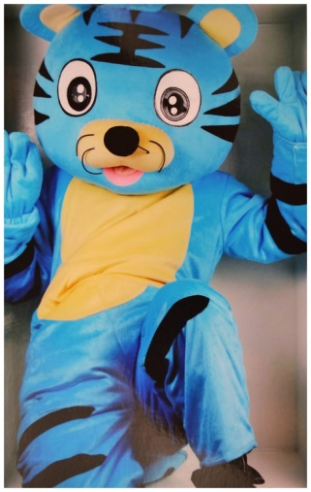
Dear Parents/Carers and Year 4 children,
We wanted to welcome you back to school and into Year 4. We hope you all had an enjoyable summer and got up to lots of fun and interesting things. As a team we are really looking forward to an exciting year ahead with lots of fun and learning along the way.
Year 4 is a great year to be in as our topics are very exciting this year and the Maths and English build on all the great things your child has already learnt. There is a step up in terms of challenge but we are aware of this and will support and encourage your child as they come across new and exciting objectives.
The team this year consists of Mr Power in 4P (who is new to Year 4 this year having previously been in Year 5), Mrs Appleton in 4A (who taught in Year 4 last year), Miss Oldfield (who will support in 4P) and Miss Meynell (who will support in 4A) and Mrs Hepworth with Mrs Moran working across both classes. In addition, Mr Bradley will also work across both classes as our learning mentor. Please feel free to come and speak to us with any questions, suggestions or concerns - we are always willing to listen and help in any way we can. We also have a year email that Mrs Appleton and Mr Power will check and respond to - year4@stthomas.org.uk.
This half-term we our Year3/4 topic is: A Matter of Life and Death
In Year 4 we will be reading Sky Hawk by Gill Lewis and using the book to look at information text and rewriting part of the story from a different point of view.
In maths we will start with place value- thinking about numbers and their worth. We will then move on to addition and subtraction and securing short methods and using them in reasoning problems.
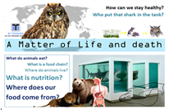
Topic will be mainly Science based thinking about food chains, teeth and digestion. We will also be looking at our country and the position of towns and cities. We hope we can share this with you. Our PE day is Monday and for this half term we will be studying dance. Children should come to school in their PE clothes on Monday.

This half-term we are lucky to have GROW working with us on a Tuesday (4A in the morning and 4P in the afternoon). The children will need to wear outdoor PE clothes (not non uniform), a coat and a change of sensible footwear such as wellies, so they can wear different shoes inside should their outdoor shoes become dirty.
This week we have had lots of activities to get to know each other and ease us all back into school, we hope the children have enjoyed them and feel part of Year 4.
Please do feel free to pop over to say hello after the children have been collected to get to know us. We look forward to getting to know your child and you over the next few weeks.
All the best,
Mrs Appleton, Mr Power and the Year 4 team

