Dear Parents, Carers and year 3 children
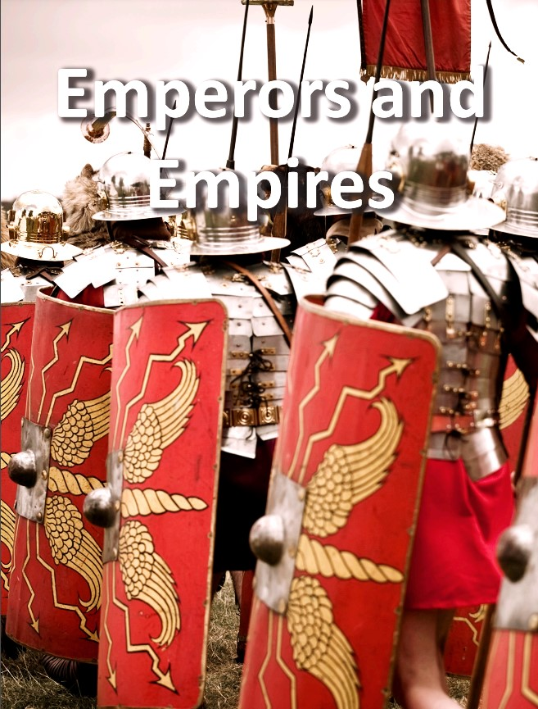
We’d like to welcome you back to school after Easter.
This term our Year 3 History topic is: Emperors and Empires

In the Emperors and Empires project, children will learn about the history and structure of ancient Rome and the Roman Empire, including a detailed exploration of the Romanisation of Britain.

Our English and Reading:
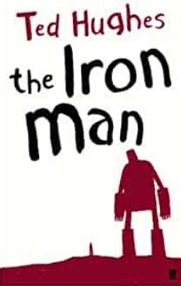

For English and Reading we will be following the book ‘The Iron Man’ by Ted Hughes. We will be working on creative story writing and exploring where the Iron may have come from. For our Reading, we will explore word meanings and vocabulary from the book as well as developing their reading fluency.
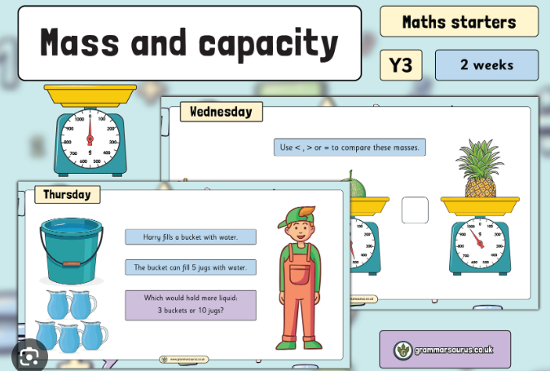

In Maths we are looking at mass and capacity then continuing with
fractions.

In Science we will learn all about plant nutrition and reproduction. Children will learn about the requirements of plants for growth and survival. They will describe the parts of flowering plants and relate structure to function, including the roots and stem for transporting water, leaves for making food and the flower for reproduction.
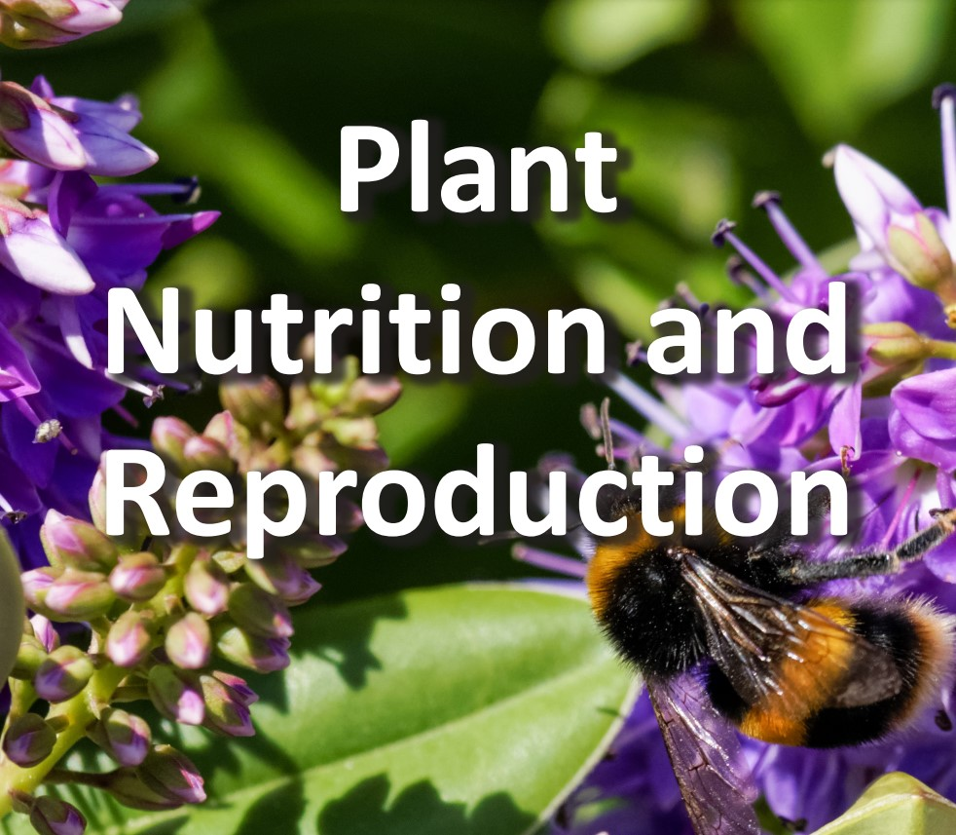

Also, this half-term Year 3 will be learning how to duel, pass and position as well as skills of accuracy power and distance in PE. We will be doing PE on an Wednesday and Friday so your child needs to come in in their correct kit on that day.
In PSHE / RSHE we will learn about why we should eat well and look after our teeth.
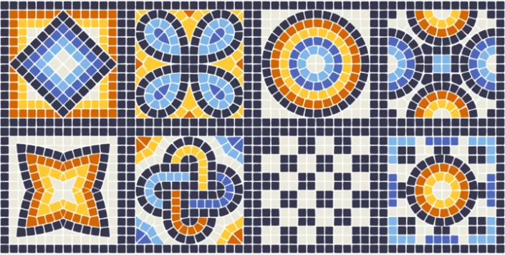

For Art and Design we will be learning about the history of mosaics, before focusing on the colours, patterns and themes found in Roman mosaic. The children will learn techniques to help them design and make a mosaic tile.

In Religious Education we will be looking at how people express spirituality.
For our Computing sessions we will be Sequencing sounds by creating sequences in a block-based programming language to make music.
Please feel free to have a quick chat on the playground and say hello to us. We are happy to answer any queries you may have about school and children’s learning.
All the best,
Miss Dickson and Mr Steels

