**St Thomas CE (VC)**

**Primary School**



**History Policy**

|  |  |
| --- | --- |
| **Policy Reviewed on:** | **July 2023** |
| **Policy approved by Governing Body on:** |  |
| **Policy to be reviewed on:** | **July 2024** |

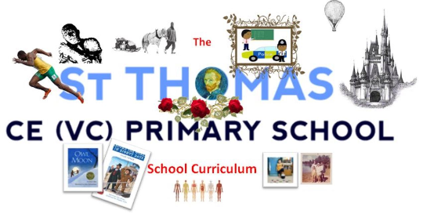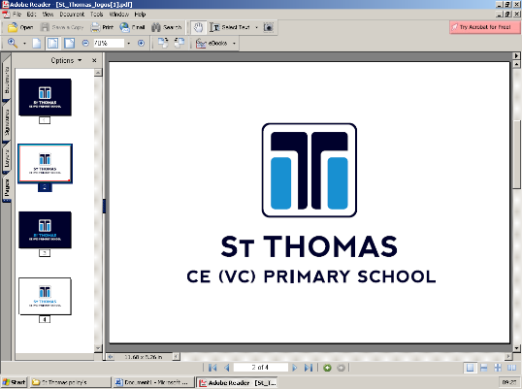

**History**

*Subject Policy*

**History at St Thomas Primary**

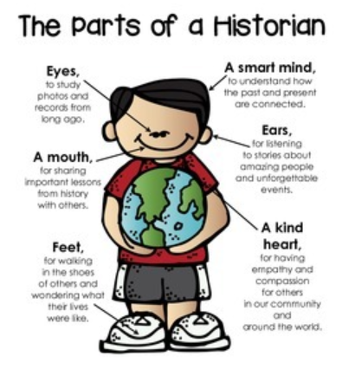**At St Thomas Primary School our aim is to provide a history curriculum which is meaningful, rich and deep. A curriculum which stimulates interest and curiosity and encourages pupils to work and think like historians with an emphasis of examining historical artefacts and primary sources. Pupils are required to identify and understand the different parts of a historian, carrying out pupil-size enquiries, so that they can actually DO history. During lessons, pupils are encouraged to ask their own questions, seeking out relevant supporting material so that they can make conclusions from the evidence before them. They know that stories from the past are often told differently and can be contradictory, so pupils are encouraged to consider the reliability of sources provided. History at St Thomas is not just about learning about the past, pupils are required to develop a set of skills which can be used during future learning and employment.** **Historical awareness is a vital and motivating aspect of pupil development. Lessons are enquiry based during which pupils discover, enquire, investigate, evaluate and conclude.**

**Intent:**

The history projects are well sequenced to provide a coherent subject scheme that develops children’s historical knowledge, skills and subject disciplines. Key aspects and concepts, such as chronology, cause and effect, similarity and difference, significance and hierarchy, are revisited throughout all projects and are developed over time. All projects also develop historical skills based on evidence and historical enquiry. The choice of historical periods follows the guidance set out in the national curriculum, with specific details relating to significant events and individuals chosen to present a rich and diverse account of British and world history. Where there are opportunities for making meaningful connections with other projects, history projects are sequenced accordingly. For example, the project Dynamic Dynasties is taught alongside the art and design project Taotie to give children a better all-round understanding of ancient Chinese arts and culture. All history projects are taught in the autumn and summer terms, with opportunities for schools to revisit historical concepts in some of the spring term geography projects.

The school curriculum is informed by the national curriculum and is sensitive to pupil interest, as well as the context of the local area. It is a bespoke, broad and balanced curriculum which is used alongside the skill progression map for history, to set out the knowledge and skills pupils will gain at each stage. First quality teaching of history occurs at St Thomas Primary, as cohort groups plan effectively, ensuring clear subject milestones and learning objectives are made, previous knowledge and skills are built upon and opportunities for revision of facts and historical understanding are made. The history curriculum is designed around the needs of the pupils in our school and there are a variety of approaches used to enable pupils to make good progress. Lessons planned have clear subject and skill intent, ensuring learning is meaningful and engaging where pupils gain knowledge and understanding of Britain’s past and that of the wider world. The work given to pupils, over time and across the school, consistently matches the aims of the curriculum.

*The aims of teaching history in our school are to develop pupils who:*

* *Develop a chronological understanding, putting time periods in context with those previously studied. Connections are constantly being made in history lessons and across the broader curriculum.*
* *Understand historical concepts such as continuity and change, cause and consequences and use them to make connections.*
* *Are able to write and talk about the past, showing an understanding of the impact a time period has had on our lives today.*
* *Ask historically valid and deep questions and create their own structured accounts, including narratives and analysis.*
* *Analyse evidence and question its validity.*
* *Are interested in the past and have developed an understanding that enables them to enjoy all that history has to offer;*
* *Know about significant events in British history and understand how Britain has influenced the wider world.*
* *Understand how Britain is part of a wider European culture and to study some aspects of European history.*
* *Develop a knowledge and understanding of historical developments in the wider world, including ancient civilisations empires and past non-European societies.*
* *Understand society and their place within it, so that they develop a sense of their cultural heritage;*
* *Apply the skills of enquiry in which they**discover, enquire, investigate, evaluate and conclude.*
* *Gain historical perspective by placing their growing knowledge into different contexts.*

All classes, in each year group will be given the opportunity to practice these skills with an aim to link ‘then’ with ‘now’.

**Special Educational Needs Disability (SEND) / Pupil Premium / Higher Attainers**

At St Thomas Primary we teach history to all children whatever their ability. History forms part of the school’s curriculum which provides a broad and balanced education to ALL children.  We seek to provide suitable learning opportunities for all by matching the challenge of the task to the ability of the child. It is of great importance that all pupils are able to access the curriculum dependent on their needs. We aim to provide the best possible support for pupils who are identified SEND or in receipt of pupil premium funding. We achieve this by:

1. Providing extra resources/stimulus e.g. pictures, word banks, sentences stems.
2. Setting common tasks which are open-ended and can have a variety of responses;
3. Providing resources of different complexity depending on the ability of the child e.g. sources of evidence;
4. Using classroom assistants to support children individually or in groups.

The history curriculum is ambitious and designed to give ALL pupils the knowledge and cultural capital they need to succeed in life. We have the same high expectations for all children.

**Implementation:**

The school’s curriculum is supported by Cornerstones 22, and the subject matter and themes chosen have been carefully sequenced, considered and designed to encourage maximum pupil engagement, motivation and interest. History at St Thomas is sequenced so that new knowledge and skills build on what has previously been taught and pupils can work towards clearly defined end points. A variety of engaging and hands on learning approaches are used during the teaching of history which stimulate interest and curiosity whist examining historical artefacts and primary sources.

As pupils progress through school we provide them with a chronological understanding of the past (both in Britain and the Wider World), putting time periods in context with those previously studied. In addition we teach pupils to understand how events in the past have influenced our lives today, often through investigation. Pupils are encouraged to ask searching questions and seek out relevant supporting material in order to draw conclusions from the evidence before them. They are aware that historical accounts are often presented differently and contradictory, so they are encouraged to consider the reliability of sources provided. History is enquiry based during which pupils learn how to discover, enquire, investigate, evaluate and conclude.

History at St Thomas is designed and delivered in a way that allows pupils to transfer key knowledge to the long-term memory which is then applied fluently. It is sequenced so that new knowledge and skills build on what has been taught before and pupils can work towards clearly defined end points. Mastery of skill and knowledge is crucial, no gaps in learning should arise as pupils move onto the next stage. We teach pupils to understand how events in the past have influenced our lives today, often through investigation, during which pupils are encouraged to ask searching questions and they are taught the skills of enquiry, analysis, interpretation and problem solving. As pupils progress through school we provide them with a chronological understanding of the past, putting time periods in context with those previously studied. We want children to become great investigators in order for them to reach age related expectations. Pupil motivation and enjoyment is paramount so a variety of engaging and active approaches are encouraged. The history curriculum intends to inspire pupils to develop a love of history and see how it has shaped the world they live in.

The history projects are well sequenced to provide a coherent subject scheme that develops children’s historical knowledge, skills and subject disciplines. Key aspects and concepts, such as chronology, cause and effect, similarity and difference, significance and hierarchy, are revisited throughout all projects and are developed over time. All projects also develop historical skills based on evidence and historical enquiry. The choice of historical periods follows the guidance set out in the national curriculum, with specific details relating to significant events and individuals chosen to present a rich and diverse account of British and world history. Where there are opportunities for making meaningful connections with other projects, history projects are sequenced accordingly. For example, the project Dynamic Dynasties is taught alongside the art and design project Taotie to give children a better all-round understanding of ancient Chinese arts and culture. All history projects are taught in the autumn and summer terms, with opportunities for schools to revisit historical concepts in some of the spring term geography projects

**History in EYFS**

The EYFS framework is structured differently to the national curriculum as it is organised across seven areas of learning rather than subject areas. However, at St Thomas it is of primary importance that pupils develop skills early on so we have identified which early years outcomes are prerequisite skills for history within the national curriculum. The most relevant early years outcomes for history are taken from the following areas of learning:

* Understanding the World.

History makes a significant contribution to the ELG objectives of developing a child’s knowledge and understanding of the world through activities such as exploring historical artefacts, looking and discussing pictures of famous people in history or discovering the meaning of new and old in relation to their own lives. Historical vocabulary is also introduced and developed to enable children to discuss their ideas fully. The early learning goals at EYFS are very much focused on the memories of the child. They are asked to remember special events, routines and/or customs for their family. In addition, pupils are encouraged to talk about differences between different family members and/or different generations.

**Key Stage 1 (Years 1 and 2)**

In Year 1, children begin the autumn term by studying the project Childhood. This project builds on children’s past experiences, including their family history and events within living memory, and works well as an introductory project. In the summer term, children study the project School Days. This project enables children to learn the history of their school and compare schooling in the Victorian period. In the autumn term of Year 2, children extend their studies to explore a broader range of periods in the project Movers and Shakers. This project explores the concept of significance and the significant people that have greatly influenced history. In the summer term, children study the project Magnificent Monarchs. This project introduces children to the challenging concepts of power and monarchy in preparation for more complex historical topics in Key Stage 2. The projects studied in Key Stage 1 provide numerous opportunities for children to explore significant historical events, people and places in their locality.

**Lower Key Stage 2**

In Year 3, children begin the autumn term by studying the chronology of British history in the project Through the Ages. This project teaches children about the significance of prehistoric periods and the changes in Britain from the Stone Age to the Iron Age. In the summer term, children continue to develop their knowledge of the chronology of British history in the project Emperors and Empires. This project teaches children about the Roman Empire, its invasion of Britain and Britain’s ensuing Romanisation. In the autumn term of Year 4, children resume their learning about British history in the project Invasion. This project teaches children about the Roman withdrawal and the invasion and settlement of the Anglo-Saxons and Vikings. This project concludes at 1066, which meets the guidance from the national curriculum for British history. In the summer term of Year 4, children begin their studies of ancient history by studying the overview project Ancient Civilisations. This project enables children to learn about the achievements of the earliest civilisations, including ancient Sumer, the Indus Valley civilisation and ancient Egypt.

**Upper Key Stage 2**

In the autumn term of Year 5, children continue to build their knowledge of ancient civilisations with an in-depth analysis of ancient China in the project Dynamic Dynasties. This project enables children to study the significance and influence of ancient China and its prowess and advancements in the written word, technology and metalwork. In the summer term, children further study ancient and world history in the project Groundbreaking Greeks. This project enables children to explore life in ancient Greece, including examining the achievements and influence of ancient Greece on the western world. In the autumn term of Year 6, children study the more complex historical issues of enslavement, colonialism and power in the project Maafa. In this project, children explore a range of African kingdoms, including the Kingdom of Benin, and study Britain’s role in the development, perpetuation and abolition of the slave trade. In the summer term of Year 6, children complete their historical studies with the project Britain at War. This project enables children to study the role war has played in Britain’s history since 1066, focusing on the First and Second World Wars as crucial turning points in British history**.**

Visiting sites of historical significance and inviting history specialists into school to talk about their experiences/understanding of events in the past, are key to providing a rich and valuable historical experience as well as a knowledge base for children at St Thomas Primary.

Throughout all the history curriculum the children will also get local history knowledge carefully linked with the projects to ensure that they understand the impact history has had on the areas around them and how it has shaped their lives.

**Impact:**

Assessment of history at both KS1 and KS2 will be based on teachers’ judgments. Assessment takes place at all appropriate stages of a lesson to ensure pupils understand and can work to their true potential throughout the lesson, but particularly within the plenary, focusing on the relevant learning objectives to the lesson. All AFL is used to identify gaps in pupil knowledge and skill which informs next steps. Pupils are encouraged to be active in their learning, considering where they are now, where they are going and how they are going to get there. AFL can take the form of questioning, feedback, peer assessment and or self-assessment. We assess how well pupils embed concepts in their long-term memory and apply them fluently; developing their understanding rather than memorising disconnected facts. If children are keeping up with the curriculum and are developing the skills required at each stage of learning (skill progression map for history), they are deemed to be making expected or more than expected progress.

**Leadership and Management**

The subject leader's role is to empower colleagues to teach History to a high standard and support staff in the following ways:

* By keeping up to date on current issues and developments in primary history; disseminating relevant information and providing training for staff members (either directly or through other professionals).
* Leading by example by modelling lessons or styles of teaching.
* Having knowledge of the quality of history provision across the school and using this to provide a coaching and mentoring role.
* Identifying and acting on development needs of staff members. Staff supported to address gaps in their knowledge so that pupils are not disadvantaged by ineffective teaching.
* Monitoring expectations, provision and attainment across the school and providing feedback to develop practice further in order to raise standards.
* Taking a whole-school strategic approach to the spiritual, cultural and moral development of pupils, to make the world a better place.
* Ensuring the history curriculum builds towards clear end-points e.g. what pupils are expected to know and do (skills) by each of these end-points e.g. by the end of a year, key stage or phase of schooling.
* Promoting history by mentioning/highlighting good practice.
* Making sure the pupils know that history is valued through display, celebration, themed days.

**Monitoring and Evaluation**

A range of monitoring techniques are used by the history subject leader to ensure first quality teaching and learning of history is taking place within school and these include book scrutiny, planning scrutiny, planning drop ins, talking with pupils (What helps them? What don’t they understand/enjoy?) and learning walks. The quality of teaching and learning is also monitored as part of the appraisal process.

**Partnerships with Parents**

Parents are kept informed of topics that are being covered through the termly newsletter. In addition, at the end of each academic year, parents receive their child’s yearly report which clearly indicates pupil effort and attainment in this area of the curriculum. Parents also have access to the history curriculum policy on the school website, where they will also find a page specifically for history which contains information about the history topics covered, celebrated work and links to suitable informative/learning web pages.