Calculations Policy

When faced with a calculation problem, encourage your class to ask……

Can I do this in my head?
Could I do this in my head using drawings or jottings to help me?
Do I need to use a written method?
Should I use a calculator?

Also help your class to estimate and then check the answer. Encourage them to ask……

Is the answer sensible?

 | L1 | L2 | L3 | L4 | L5
Addition | Med:6+4  High:12+6 | Med: 35+27  High: 58+36 | Low: 78+57  Med:549+276 | 2734+1258 | 15.35+24.8
Subtraction | 6-3 | 45-27 | Low: 136-78  Med: 549-276 | 2734-1258  Difference (time)  8:35 to 13:25  Difference (Money)  £5.15-£2.36 | 21.05-14.84
Division | I have 4 (6 etc) socks.  How many pairs do I have? | How many 2p coins make 20p?  12 ÷ 3 = | Low: 22 ÷ 7  Med: 63 ÷ 4 | 362 ÷ 8 | 347 ÷ 12  87.5 ÷ 7
Multiplication | One bike has 2 wheels.  How many wheels do two (three etc) bikes have? |   There are 10 crayons in each box.  How many crayons are there altogether? | 63 x 4 | med: 362 x 8  High: 62x28 | 31.62x7  345x23
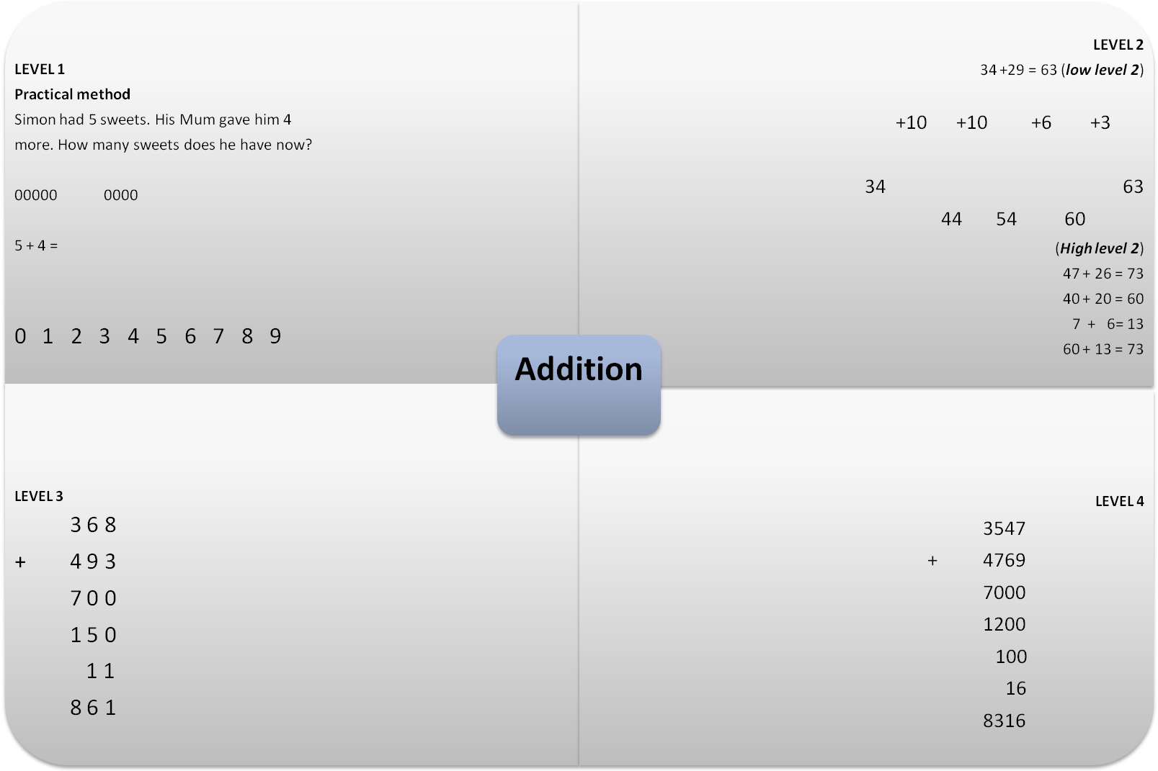
The child is using concrete resources (sweets) to introduce addition
Simple addition calculations where you add single digits together.
The number line helps the child to count up in ones.

Adding 4 digit numbers together.
Begin with the thousands, next the hundreds, then the tens and finally the ones. Recombine mentally.

7000 + 1000 = 8000
8000 + 200 = 8200
8200 + 100 = 8300
8300 + 16 = 8316

Adding 3 digit numbers together.
Begin with the hundreds, next the tens and finally the ones. Recombine mentally

700 + 100 = 800
800 + 50 = 850
850 + 10 = 860
860 + 1 = 861

Children to add smallest 2 digit number to biggest 2 – digit number. Add tens on first. Begin with adding one ten at a time. Once the children are confident, children to add multiples of 10.
Then add the units. Partition the number so that the number reaches the next ten then add the rest e.g. 54 + 9 =
Partition 9 into 6 and 3. Add 6 to 54 to reach the next ten then add 3 (the rest of 9)
Adding 2 digit numbers together. First partition both numbers. Add the tens together. Then the ones. Add the totals together for your answer.

NOTE: the answer should be under 100.
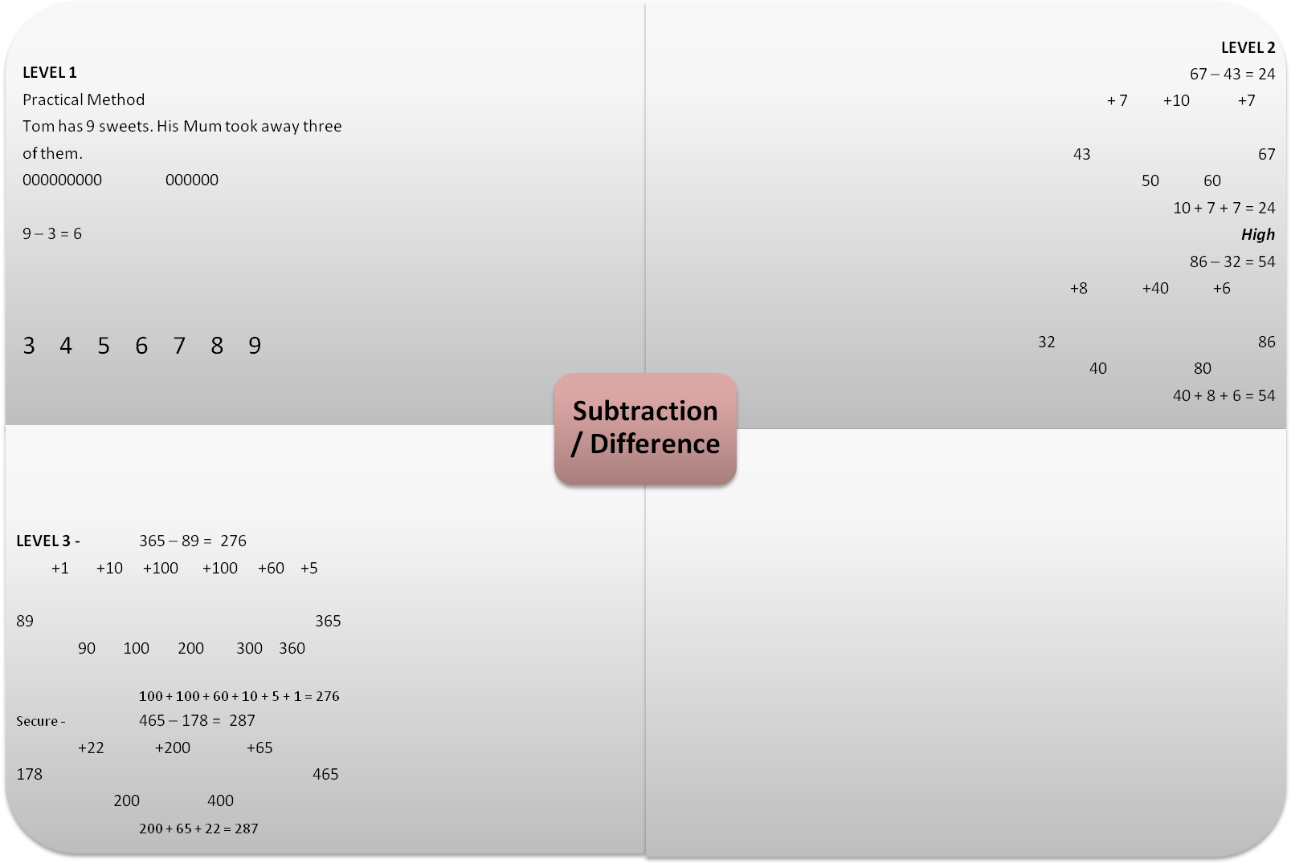

Using concrete resources helps children to understand subtraction.

NOTE:
(Before using this) Children at this level must understand (concrete) the concept of taking away from the larger number to finish with a smaller number.

Children to find the difference between a 4 – digit number and a 3 digit number. Begin with the smallest number and end with the biggest number. Children should be taking bigger steps to reach the end number. To find the answer add numbers above the number line mentally (start with the largest numbers first).
NOTE: if children are struggling allow children to use level 4 addition method.

Children to find the difference between 4 – digit numbers. As before begin with smallest number end with largest number. Take big number steps to reach the end number. Add them together mentally if possible.

Low level 3 – subtracting 2 – digit number from 3 – digit numbers using the number line. Add number above the number line together starting with the biggest number and ending with the smallest.
Secure level 3
Children finding the difference between three digit numbers. Bigger steps are taken because children are more confident with number bonds and adding mentally.
Secure level 2
Use the number line. Begin with the smallest number in the calculation and end with the biggest number. Explain to the children that you are working out the difference. First count to the next ten note how far you have counted. Then move on to counting in tens till this is no longer viable. Add on units till you reach the number at the end of the line. Add numbers above number line to work out answer. Biggest number to smallest.

High level 2
Continue to use the number line to work out difference. Children should now feel confident adding multiples of 10 along the number line.

LEVEL 4
low 1563 – 278 = 1285
+22 +700 +500 +63

278 1563
300 1000 1500

700 + 500 + 22 + 63 = 1285

Secure

3865 – 1253 = 2612

+ 47 +700 +1000 +865

1253 3865
1300 2000 3000

1000 + 700 + 865 + 47 = 2612

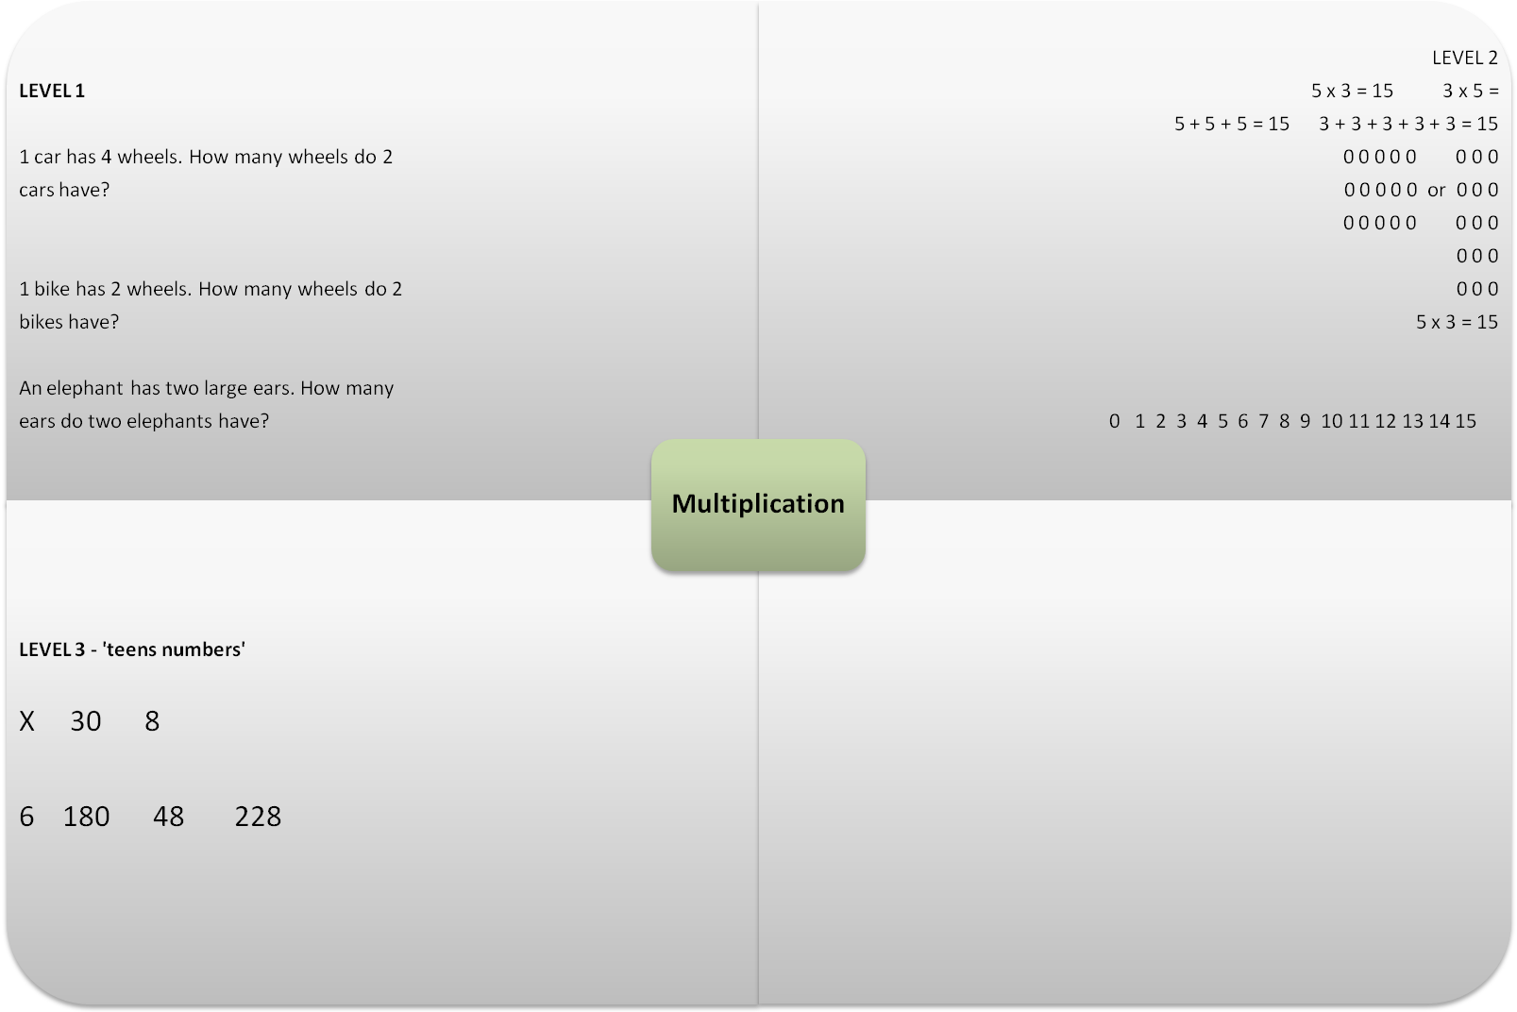

Introducing multiplication through number sentences and concrete resources. Get the children counting and talking through what they are doing.

Using the grid method to multiply a 3 – digit number by a single digit number.
Using the grid method to multiply 2, 2 digit numbers together.
Note: the extra column is added so children can add up their answers.

Use the grid method to multiply 2 – digit number by 1 – digit number.
First partition the 2 digit number. Next multiply the tens and then multiply the ones. Add the two answers together.
NOTE: practical methods like the basket model need to be used before attempting chunking method.

understanding that 5 x 3 is the same as 3 x 5.

Using the number line helps develop children’s understanding that multiplication is repeated addition.

LEVEL 4
Level 4 (secure) 239 x 6 = 1434
X 200 30 9
6 1200 180 54 1434
Level 4
56 x 27 = 1512
X 50 6
20 1000 120 1120
7 350 42 392 1512

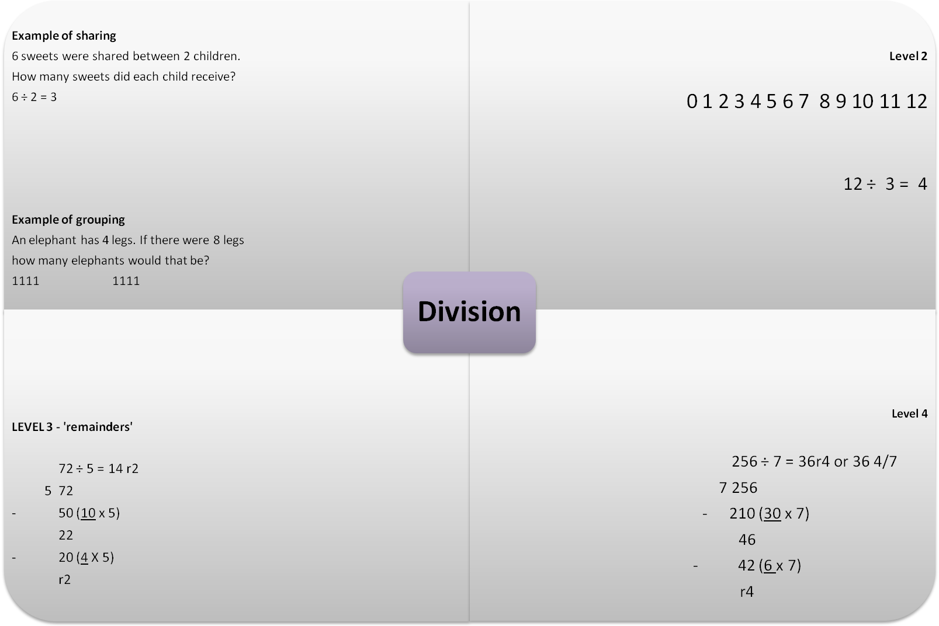

Division can be known as sharing or grouping depending on the context of the problem.
Children are to use practical and pictorial ways of working out a division calculation.
NOTE: concentrate on numbers up to 10.

Use chunking method to divide 3 digit numbers by a single digit number.

Use place value to correctly layout digits.

Use chunking method to divide 2 - digit number by a single digit number.
Note: children to concentrate on taking away multiples of 10 NO MORE!!
Use place value to correctly layout digits.
NOTE: Underline multiples

Introduce ÷ as repeated subtraction by using a number line.
The middle number in the calculation e.g. 3 in this particular calculation is the number count back in till you reach 0.
Count the number of jumps to get total.
Link to inverse.
12 ÷ 3 = 4
4 x 3 = 12

NOTE: work with numbers bigger than 10.

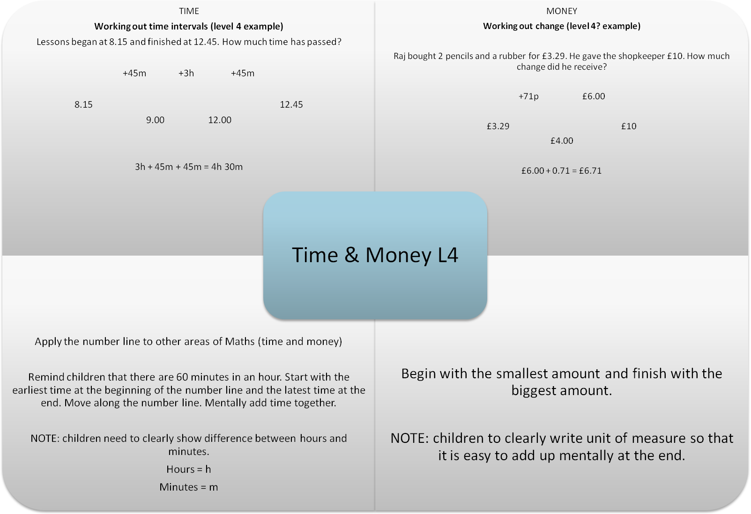
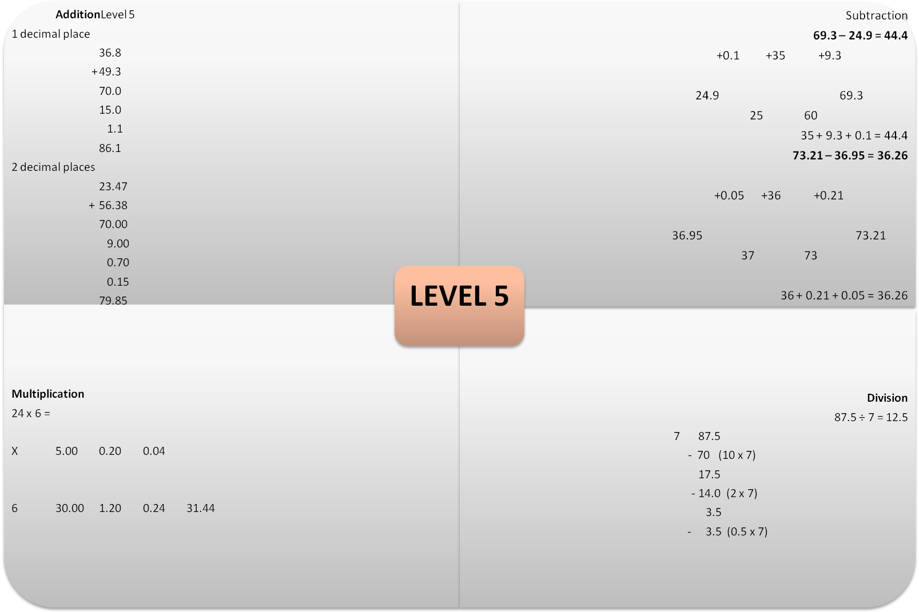

Adding decimal numbers together
Firstly to 1 place.
Add together mentally
70.0 + 10 = 80
80 + 5 = 85
85 + 1 = 86
86 + 0.1 = 86.1

Then to 2 places.
Add together mentally
70 + 9 = 79
79 + 0.7 = 79.7
79.7 + 0.1 = 79.8
79.8 + 0.05 = 79.85

Use chunking method to divide decimal numbers by a single digit.

Use place value to correctly layout the digits.

Using grid method to multiply whole numbers to decimals (1 place).
Then moving on to multiplying decimals to 1 place together.
Note: extra 0 at the end of the decimal to help child with adding at the end of the calculation.

Use the number line to subtract decimals to 1 and 2 decimal places.

