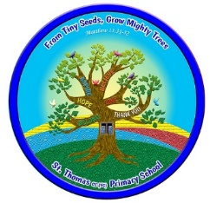**Design & Technology**

Long Term Plan 2024-2025

|  |  |  |  |  |  |
| --- | --- | --- | --- | --- | --- |
|  | **Autumn** | | **Spring** | **Summer** | |
| **Reception** | **Pupils explore and use a variety of media and materials through a combination of child initiated and adult direct activities. Outdoor learning provides opportunities to work on a large scale and by using natural resources.** | | | | |
| **Year 1** | **Shade and Shelter**  **structures** | **Taxi!**  **mechanisms** | | **Chop, Slice and Mash**  **cooking and nutrition** | |
| **Year 2** | **Remarkable Recipes**  **cooking and nutrition** | **Beach Hut**  **structures** | | **Cut, Stitch and Join**  **textiles** | **Push and Pull** **mechanisms** |
| **Year 3** | **Cook Well, Eatwell**  **cooking and nutrition** | **Making It Move**  **mechanisms** | | **Greenhouse**  **structures** | |
| **Year 4** | **Fresh Food, Good Food**  **cooking and nutrition** | **Functional and Fancy Fabrics**  **textiles** | | **Tomb Builders**  **structures** | |
| **Year 5** | **Moving Mechanisms**  **mechanisms** | **Eat the Seasons**  **cooking and nutrition** | | **Architecture**  **structures** | |
| **Year 6** | **Food for Life**  **cooking and nutrition** | **Engineer**  **mechanisms** | | **Make Do and Mend** **textiles** | |